**Practical Life Album**

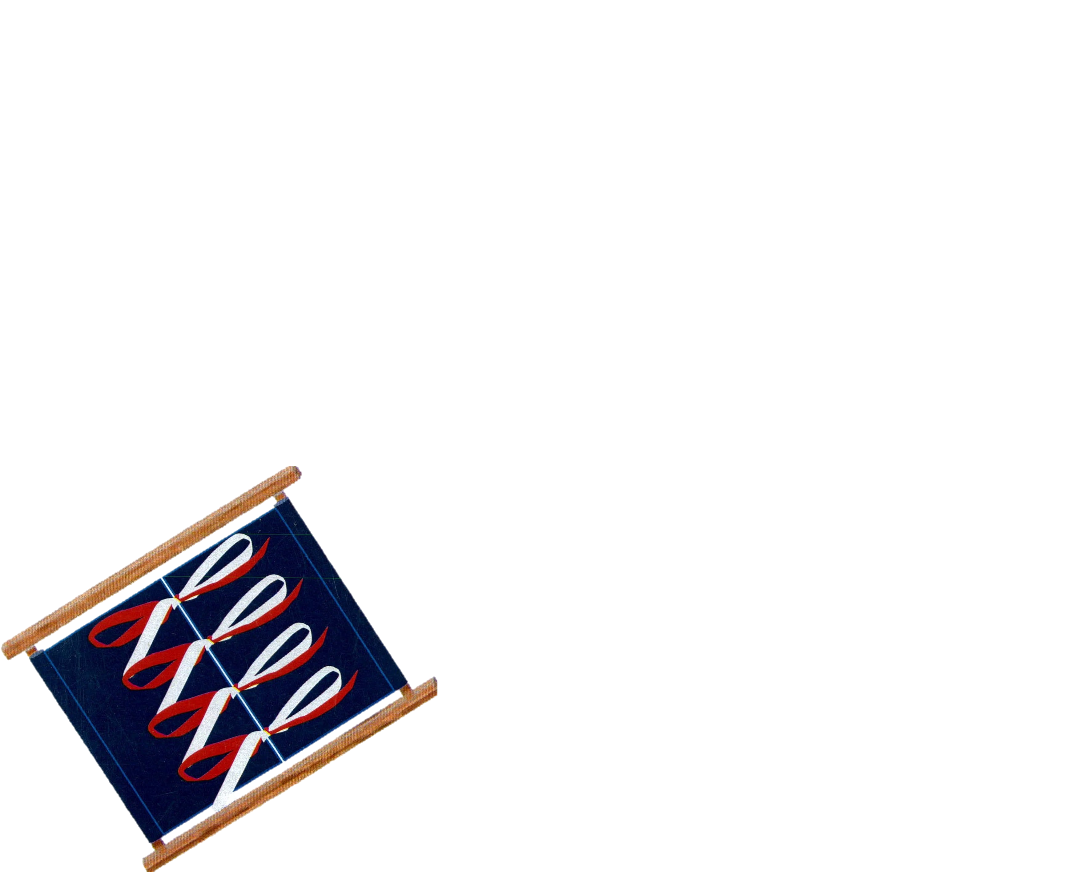

Ivan, John, Tredoux

Table of Contents

INTRODUCTION TO PRACTICAL LIFE 7

PURPOSE OF PRACTICAL LIFE 8

GROUPS OF PRACTICAL LIFE EXERCISES 10

1 PRELIMINARY EXERCISES 10

1. CARE OF THE ENVIRONMENT (INDOOR AND OUTDOOR) 10
2. CARE OF SELF AND OTHERS 10
3. GRACE AND COURTESY ........................................................................, 10
4. MOVEMENT 10

RESPONSIBILITY OF THE ADULT 11

* 1. PREPARATION OF SELF 11
  2. PREPARATION OF THE ENVIRONMENT 11
  3. DAILY PREPARATION 11
  4. PRESENTATIONS 11
  5. BEGINNING, MIDDLE, END 12
  6. ANALYSIS OF MOVEMENT 12
  7. GRANT FREEDOM 12
  8. FOLLOW UP 13
  9. MAINTAIN HARMONY 13

CHARACTERISTICS OF THE PRACTICAL LIFE MATERIALS 14

**TYPES OF MOVEMENT 15**

**THE RELATIONSHIPS OF PRACTICAL LIFE 16**

1. ADAPTATION 16
2. INDEPENDENCE 16
3. ABSORBENT MIND 16
4. SENSITIVE PERIODS 16

**PRACTICAL LIFE PRESENTATIONS 17**

**PERENNIALS** 18

*Presentations 18*

*General* Notes 18

* 1. *Procedure for Pouring Water from the Tap 18*
  2. *Procedure for Pouring Water from a Container 19*
  3. *Procedure for Pouring Water into the Sink* 19
  4. *Folding an Apron 19*
  5. *Folding a* Mitt 19
  6. *Folding a Buff* Pad *19*
  7. *Folding* a sleeve *19*

**PRELIMINARY EXERCISES** 21

Walking 21

Standing *23*

*Sitting Down and Getting Up* * Floor *24*

*Sitting Down and Getting Up* - Chair *25*

*Carrying a* Chair *26*

*Carrying a* Table *27*

*Carrying Trays or* Boxes *28*

*Carrying a* Bucket *29*

*Carrying* a *Jug, Fill and Empty* 30

*Opening and Closing Drawers 31*

*Opening and Closing a* Door *32*

4

*Turning a Light Off and* On *33*

**EXERCISES** 34

*Boxes and* Bottles................................................................................................ *34*

*Locks and* Keys *35*

*Nuts and Bolts #1 36*

*Nuts and Bolts* #2 *37*

*Using a Screwdriver 38*

*Washing Hands at* Tap *39*

*Squeezing a* Sponge *40*

*Wringing a* Cloth *41*

*Pouring* Rice *42*

*Pouring Water #1* - *Jug to* Jug *43*

*Pouring Water #2* - *Jug to* Glass *44*

*Pouring Water #3* - *Jug to* Glasses *45*

*Pouring Water #4* - *Jug to Glasses at Various Levels 46*

*Pouring Water* #5 - *Teapot to Tea Cup and* Saucer *47*

*Spooning 48*

*Carrying, Rolling and Unrolfing* Mats *49*

*Folding* Cloths *50*

**CARE OF THE ENVIRONMENT** - **INDOORS** ..................... 52

Sweeping *52*

*Brushing* Mats *53*

Dusting........................................................................................................................................................ *54*

*Sponging Up* Spills *55*

*Polishing* Glass *57*

*Polishing* Wood *58*

*Polishing* Metal *60*

*Washing a* Table *62*

*Washing* Linen *65*

*Sewing on a Button 67*

Ironing *69*

*Folding* Clothes *71*

*Care of* Plants *72*

Flowers *74*

*Flower Arranging 76*

*Lighting a* Match *78*

*Cutting Snippets 79*

*Cutting Lined* Paper *80*

*Cutting Newsprint 81*

Pasting *82*

*Making a* Cord *84*

**CARE OF THE ENVIRONMENT- OUTDOORS** 85

**CARE OF THE PERSON** 87

*Washing Hands and* Nails *87*

*Brushing* Clothes *89*

*Hanging Clothes on* a Hanger *90*

*Cleaning* Shoes *91*

*Dressing* Frames *93*

*Large Button Dressing* Frame *94*

*Small Button Dressing Frame 95*

*Snap Dressing* Frame *96*

*Zipper Dressing* Frame *98*

*Hooks and Eyes Dressing* Frame *99*

*Buckle Dressing Fran1e 100*

*Bow Dressing* Frame *101*

*Safety Pin Dressing* Frame *103*

s

*Shoe Lacing Dressing Frame 104*

*Skate Lacing Dressing* Frame 105

*Buttons with* Hook. *106*

*Blowing Nose* 107

**GRACE AND COURTESY 108**

*Greeting and Introducing 109*

*Offering to a* Guest *109*

*Giving and Receiving Compliments 110*

*Making Way for* Someone *to* Pass.............................................................. 110

*Interrupting* Someone *110*

*Sneezing, Yawning, Coughing* 111

**MOVEMENT** 112

*Walking on the* Line *112*

*The Silence* Game 114

*Introduction to Practical Life*

The area of Practical Life is a distillation of the activities undertaken by the adults of the human species to:

1. Establish a living environment that contains specific areas pertaining to practical life, sensorial, language, etc.
2. Preserve the environment by cleaning, washing, dusting, and keeping everything in its own place. Presenting the preliminary exercises at the very beginning of the year helps the children become responsible for their environment, and encourages independence and self-sufficiency.
3. **Embellish the living environment** and the self. It means keeping everything clean and beautiful, having fresh arrangements of flowers and other beautiful things for the children to look at. This should include moral embellishments of grace and courtesy that can be shown to the children throughout each day. As well, this should include the care of self. It is important to clean and adorn yourself in a positive manner, show your self-respect and your dignity.
4. **Care for others** within the environment. The older children help the younger children, and all children learn not to disturb one another when they are working. The children are shown how to care for others through presentations of practical life (i.e. Washing linen, ironing), and by the teachers daily actions. Children learn how to share their environment, to care and respect one another through the use of the materials and: by concrete examples. There is only one material for each exercise, therefore children learn to wait for that child to finish with it, and return it to the shelf before they can use it. This can sometimes call for great patience when one child is really caught up in a particular developmental material.
5. Be Hospitable and create Ceremony Take all opportunities to be hospitable. It is an opportunity to show the children grace and courtesy to guests that come to your classroom. Cherish the guests that come to visit. Ask the guests not to disturb the children, to sit quietly and observe, and ask questions later. Celebrations in the classroom are important. But what is most important is that they must be done with dignity and not by rote. Celebrations should not be long and drawn out, part of a morning or of an afternoon are sufficient for the celebration. As well, children should not be forced to participate in a ceremony they don't wish to. It is important to celebrate a variety of occasions, especially if there is a wide cultural mix in the classroom. Whatever the celebrations, make it beautiful, and always remember **what** you are celebrating (is it historical, religious, or traditional?) and **why** you are celebrating it. Celebrate the occasion in its entire means; poetry, painting, literature, music, food, etc. Try and develop a functional exercise with the celebration: make a small area for those who would like to participate in making something (Christmas craft corner, painting Easter eggs, making paper turkeys etc.)

Practical Life activities are an introduction to the basic activities that the child can find at home. The child will learn skills that will allow him to take part in adult activities and gain independence. The exercises of Practical Life are a key to the child's world. They give a basis and foundation for the child to function successfully in his environment now, and in the future.

**Purpose of Practical Life**

It is the children themselves who initiate the practical life activities. The children will take these activities spontaneously because they have chosen them. Children are passionately interested in these activities because the activities respond to all the sensitive periods. Practical life builds a foundation on which the children will grow. The exercises respond to the need for:

Order of activities (sequences, routine, hierarchy, a cycle or full rotation of an activity).

e **Movement.** All practical life exercises involve great movements that are varied and attractive. All the various movements help the child's self-awareness within the environment and increase the child's acquisition of intelligent movement.

G **Sensorial exploration** (sights, sounds, smells, and eventually language).

* Needs and tendencies are responded to, to help the children adapt to their environment so that they can actively participate and grow within their environment.

e **Orientation and Independence** within their environment.

"' **A Childs love of work.** Practical life activities feed their natural desire to work and be an active part of their environment.

Practical Life leads to:

i. Construction and integration of the child's personality through their freedom of choice, and through the variety of their choices. Freedom of choice is necessary for the healthy **development of the will.**

1. A spontaneous, purposeful activity that is only possible when children are allowed to exercise their curiosity through repetition. It is only through repetition that abstraction is possible. This abstraction brings about a feeling of completion for the growing child.
2. Development of co-ordination of movement. The child thinks of the activity, wills himself to the activity, and then does the activity.
3. Development of the physical, mental, and emotional aspects ofthe child.
4. **Purposeful movement** that helps the development of the mind, and a sense of achievement. The development of the child's mind, movement, and senses will in turn, develop the will.
5. **Concentration.** The child will concentrate on completing an activity as perfectly as possible; all activities are intelligible, logical, sequential, and exact. Children will internalize this and try to repeat the exercises as perfectly as possible; all exercises have a motive for perfection.
6. Orderly work habits. The children need to internalize presentations in an orderly manner in order to reproduce it in an orderly manner.
7. The practical life exercises develop logical thought through the definite logic in the exercises. There is a beginning, middle, and an end to each exercise.
8. The exercises give the children a sense of responsibility from the result of freedom (freedom which is a result of co-ordination of movement and awareness of the environment). Children have the freedom and the ability to exercise their will within their environment.
9. Social development. All of the practical life exercises teach the children grace, courtesy, patience, and respect. These elements of social development are re-enforced through the actions of the other children and through the actions of the teacher.
10. Establish a sense of reality, rooted in real activities (nothing is make-believe). Exercises are lucid, logical, and realistic. This helps the children pursue reality. If an activity is not meaningful and purposeful than the mind cannot develop or construct itself.
11. Emotional stability helps the children become familiar with the real world and their environment. It builds self-esteem, and through that, their dignity will flourish. Materials and activities are therapeutic, meaning the mind and body work together.

Groups of Practical Life Exercises

1. Preliminary exercises

Preliminary exercises are the basis of the classroom and guarantee the success of all future exercises. They establish the functioning of the class and are the foundation on which the children will build their behavior. The exercises help to make the children aware of their will, co-ordination, concentration, and logical thought

1. Care of the environment (indoor and outdoor)

Environment exercises show the children respect for the indoor and outdoor environment, and how to take responsibility of the environment they live within. It gives them the ability to care for those things which are necessary in the environment. These exercises include washing a table, wiping up spills, pouring, washing clothes, ironing, and many more.

1. Care of self and others

Care of self and others are very important to the children. These exercises enable children to become independent, give them dignity, self-esteem, and personal stability. These exercises also give the children the opportunity the help not only themselves but others. They improve social relations and respect for others which are the foundation for our personal relationships and our society.

1. Grace and courtesy

Grace and courtesy underlie all of Montessori pedagogy. There is an innate respect in children, which can be destroyed or nurtured while growing up, depending on the environment provided. There should be a feeling of respect and delight for each other's existence in the classroom, which will hopefully extend into the home and other aspects of life. In nature, there are no rewards and punishments, only consequences. All children need the opportunity to explore and experience all of the various graces and courtesies of different cultures. We have to treat children with the respect they deserve and help them make their way through the world with grace and courtesy. Children love the formalities of grace and courtesy and adults can teach the children grace and courtesy by always showing them how to act gracious and courteously. Adults should never give up an opportunity to be courteous and gracious as children learn by example and observation.

1. Movement

The development of the mind comes from movement. Movement exercises bring the children to an awareness of their own physical body and how it can move in the environment. The movement exercises such as walking on the line (with the many variations) help the children achieve equilibrium, correct any posture defects, and help them to acquire a good posture and gait. On the other hand, the 'Silence Game' requires the ability to control and stop all movement to the point of being able to sit very quietly and hear the silence, so that the children can hear a whisper of their name across the room.

Responsibility of the Adult

1. Preparation of self

The educator of the children becomes the center of the classroom. Each class reflects the character of the educator. It is therefore extremely important that the educator has a vision of the classroom. The classroom must be clearly prepared for the arrival of the children and their desire to learn. The educator must have a thorough knowledge of all the exercises and feel at ease with them. The educator needs to be able to present the materials to the children with grace and importance. Above all, the educator must have a belief in the children. There must be faith that the children will grow and love and believe in themselves.

1. Preparation of the Environment

The most important thing for the educator to do when preparing their environment is to prepare it according to their own vision. It needs to be an environment that has been envisioned by someone who is going to care for the children. It needs to be claimed by the educator that is going to take the room over. New environments should be put together from scratch, making the possibilities endless. Those who are taking over an already established classroom need to add some of their own materials, and change the room around according to what their own vision is. if any materials are added, it should be the practical life materials (buy a new pot, tray, cloths etc.). What is most important, whether a classroom is old or brand new, is that the classroom and all of its contents must be appealing to the children. Everything must be the best that is possible - the children deserve the best that there is. They are, after all, forming themselves from the materials that exist in the classroom.

1. Daily preparation

Both the educator and the children will be able to get off to a great start in the morning if the classroom is ready for the arrival of the children. The educator should arrive early enough in the morning to settle themselves down before the children arrive. There should be some sort of a daily routine that is established in the beginning of the year that the children can feel comfortable with. All of the sponges should be wet, and the containers that require water should be filled. All of the preparation that is necessary for the children to begin work needs to be done before the children arrive. This allows for the children to start their work as soon as they arrive without delay. This preparation of wetting the sponges, etc. can be done by a willing older child who arrives earlier than the rest of them in the morning. The educator should give him or herself a few minutes to mentally, physically, and spiritually prepare for the children's arrival. Greeting the children and listening to any stories that the children feel they need to tell you before getting down to work, is an important start to the day.

1. Presentations
   1. Preparation of Presentations - In order for any presentation to go smoothly it should be rehearsed several times before it is given to the children. This is especially important if the material has not been presented in a while and the hands have lost some of their grace with the material. If it is not rehearsed the hands will fumble and the child will become confused with the material and possibly lose interest in it.
   2. Giving presentations - Presentations that are simple, graceful, have economic, non­ idiosyncratic movements are the most effective and pleasurable for the children. There should not be any hesitations or the children will pick up on your hesitancy. Clear and

precise movements allow for them to understand and repeat the movement, which leads to achievement on their part. If a child is not ready or interested than the educator

must not present the material or they will risk turning the child away from the material for . some time. Presentations are a personal relationship - a gift of giving the children the ability to do something for themselves. You are presenting a new possibility of development; it is not a lesson.

* 1. Types of Presentations

*Individual:* presentation is addressed to one child only. Others can look on, but they are not part of the presentation and the educator should not present to them. This is very important to all of the children because it gives each child a sense of being important, worthy of a presentation all to themselves

***Group:*** no more than 3; present only to that group of three, more can look on, but they are not part of the presentation.

***Collective:*** a presentation to the entire class near the beginning of the year to outline rules, regulations, procedures, etc. This is usually how the preliminary exercises are presented.

1. Beginning, Middle. End

All presentations should begin and end at the same place. If a presentation is started by taking the material off of the shelf, then it should end with the material being put back on the same shelf. Always accompany the child to the shelf even if the child already knows where the material is. Picking up the material from the shelf is important - it is the beginning of the process of the presentation. The child needs the beginning, middle, and the end of the presentation in order for it to make sense.

1. Analysis of Movement

All movement must be broken down slowly so as to make it clear to the child. This allows the child to absorb the exactness of the movement which is important if the child is going to repeat the exercise. The educator can never let the movement be routine, it is always something that he/she is giving the child for the first time.

1. Grant Freedom
   1. *Freedom* of *Choice:* The children must have total freedom to choose the material that they wish to work with (providing another child is not already using it). They must be able to spontaneously choose the material they feel compelled to work with.
   2. *Freedom to Repeat:* As well, the children must have the freedom to complete the cycle of activity. They need to feel a sense of timelessness; they shouldn't be bothered and taken away from their work. The children need to be able to repeat an exercise without a teacher being impatient, ever. A child should never be made to feel that they are wasting someone's time, or have been a wasted effort.
   3. *Freedom* to *Ask:* A child needs to feel comfortable with asldng for an old presentation they are uncertain of, or a new presentation. There must be a trust between the child and the educator if the child is to progress and feel comfortable in the classroom. A

child should never be made to feel unintelligent because they require another presentation with a particular material.

1. Follow Up

After a presentation has been given, the child may want the educator to stay and watch for the first try. Or the child may want for everyone to go away. Everyone must respect the child's wish. But the educator must not completely leave the child. He/she must have their third eye watching the progress; don't hover, don't abandon. It is important to remember that all unnecessary help is a hindrance.

1. Maintain Harmony

Harmony within the classroom must be maintained without pride or anger. It should be the result of the educator's inner vision. Whatever the inner vision, it must be carried out with conviction or else the children will not believe in it. Three important rules that will help in maintaining harmony within the classroom should be upheld: Don't hurt (physically and mentally), don't destroy, and don't disturb.

**Characteristics of the Practical Life Materials**

Each material should have an inner aim, either immediate or ulterior; everything needs meaning.

1. All materials should have a point of interest. The points of interest guide the child, engage them and help lead the child towards awareness of the concepts being shown in the materials.
2. The materials must be physically and developmentally in proportion to the children. They must physically suit the size of the child and presented at the correct developmental stage.
3. Materials must be: clean, intact, complete, beautiful, and simple.
4. Materials should be **color coded.** This gives each material an identity and completeness. lt also creates harmony and calls to the children's sense of order.
5. Exercises need to **reflect the child's culture** and offer relevant hands-on experience (i.e. if the children do not wear leather shoes a shoe polishing lesson would not be relevant to their culture).
6. Materials must be placed within the reach of the child - at their eye level and accessible by their hands.
7. Materials must be **placed logically and sequential!)(.**
8. Materials must be **real and delicate.** The children must have the opportunity to become aware of the gentle way in which some things must be handled and cared for. Avoid using plastic materials. Using pottery, glass and porcelain calls attention to the children, to their awareness of their own body and movements. If the class functions well, then few things will break.

**Types of Movement**

1. When presenting you are analyzing movements. This allows for the children to internalize the movement and then repeat it. This is why precise movements are necessary during presentations.

1. Movement is in every exercise. Control and co-ordination are in every movement. This calls for perfection of both large and small movements. Perfection comes from the repetition of the movements.
2. Exercises in equilibrium assist the child with overall total coordination of their body. Walking on the line is important as it calls the child to awareness of their posture, gait, and equilibrium.
3. **Inhibition of movement** (i.e. The Silence Game). This game is difficult to play prior to the children reaching a state of normalization and exhibiting total control of their bodily movements.
4. Important to incorporate and expose children to all **styles of movement;** dance, music, sports.

###### 2 Stages of Progression in Movement

1. Acquisition of movement
2. Application of movement

Example: As a child learns to walk on the line they become aware of their posture, gatt and equilibrium. With time, the child is then able to apply the new skills he possesses with confidence when learning a new dance routine in gym class.

**When presenting** a **lesson,** the Educator must be sure:

e Their hands are turned so that the child can see clearly. e Right-handed educators must sit to the right of the child. e Left-handed educators must still to the left of the child.

e Present visibly - it is the hands that do the teaching and speaking.

**Relationships of Practical Life**

1. Adaptation

., The need and tendency to adapt is a characteristic of human beings.

® Children have a desire to interact with their environment and may not be allowed to fully participate in activities at home.

e Practical Life lessons allow for children to take in all the complexities of the environment

® Practical Life lessons help children adapt to home life activities and encourage independence.

1. Independence
   * Practical Life lessons give the child the key to independence in everyday life. These lessons help build personality, self-esteem and independence from adult interference.

e Being independent allows children to contribute and be responsible for themselves and for their environment.

* + The Practical Life lessons and materials are within reach of the child and allow them freedom to choose what they desire to work with.

1. Absorbent Mind
   * Practical Life materials allow for the incarnation of concepts through repetition.
   * Practical Life is a basis for future abstraction of concepts.
   * When very young, children do not have fixed patterns of behavior. With proper examples and opportunities, they can internalize and organize many activities and skills.

" Children are driven by their will to learn. They are internally driven to activities that will assist with their knowledge and development.

1. Sensitive Periods
   * **Order** - Physical order and orderly work habits are essential to the internalization of concepts. Neatness and order call the children to an awareness of the details and complexities within their environment. There is a definite sense of order to each lesson; placing materials out on a mat in order of use, always presenting the sequence of movements and the order of presentations in the same manner for each child.
   * **Sensorial** - Sensorial exploration builds up mental structure, and adds depth to each child's understanding of the world. It is essential that children be allowed to freely explore the Practical Life materials to further build their sensorial palettes; feel textures, smell foods, compare colors, sort objects by color/size/texture, listen to a variety of music, etc.

@ Movement - Children use movement to internalize concepts and perfect their skills and abilities. The strong, sensitive period for movement can be hindered by a child's lack of movement (either due to adult interference, or physical limitations). It is of the utmost importance to have appropriately sized objects/lessons in the environment that children can safely and freely use at will. It is through the extensive use of the Practical Life materials that children acquire greater fine motor control, learn how to co-ordinate their bodies within the environment, and how to care for things with varying degrees of fragility.

***Practical Life Presentations***

Each lesson has been prepared using the following outline where applicable:

Materials: States the required items for the lesson.

Presentation: Offers a step-by-step guide through the lesson from beginning to end.

Notes: Offers helpful notes to assist with the presentation or observation of the child and their acquisition of skills.

Points of Interest: States the guides or 'sign posts' within the material that will aid in engaging the children and lead them to successful acquisition of the skill.

**Purpose:** States the exact concept or intention of the material, either 'direct' or 'indirect'. *'Indirect Preparation'* means to receive an impression of a fact without at that moment consciously connecting it with a special purpose or meaning.

**Age:** We have given approximate ages for each of the lessons included in this manual. These ages are to be used as a guideline only. Each child will progress at their own speed and it is the responsibility of the Directress/Director to observe a child's ability prior to presenting a lesson. If a child is not adequately prepared for a lesson the outcome will not be a positive one.

**Games/Extensions:** Lists appropriate additional extensions.

**Personal Notes:** Where possible, we have made space for writing personal notes. This is useful for those who are new to giving presentations.



It is extremely important for the Directress/Director to be adequately prepared before presenting lessons to the children. It's strongly advised that several 'practice runs' of each presentation occur before introducing the material to the children.

Give each lesson with minimal hand movements, making each movement precise and any verbal commands clearly. This will allow for the beauty and the precision of the materials to call to the children. The materials will teach the children. It is your job as the Directress/Director to observe each child so that you may present the materials as they are ready for them.

**Perennials**

Remember: Preliminary exercises set the tone for the classroom for the year.

**Presentations**

0 Start at the shelf and end at the shelf

0 Accompany the child to the shelf

0 Adult carries the activity from the shelf to the table

0 Never cany more than one thing at a time

0If you are right-handed the child always sits on your left

0 Place the activity between you and the child

0 Always have a clear and defined table space when presenting something

1. When the presentation is finished invite the child to try it

If the child does not want you to watch them with the activity after your presentation, then tell the child to call you when he/she is finished, and you will help him/her to put it away

0 If the child is not at all interested in the activity, then put it away until another day

**General Notes**

Pouring exercises should be filled first thing in the morning before the class starts)

* Always use the correct names for the materials and areas of the classroom (i.e. The pouring lesson on the practical life shelf)
* If the exercise leaves the child's hands dirty or leaves a residue then make sure that they wash them

With children it is the process that counts, not the end product

1. Procedure for Pouring Water from the Tap

Take the container to the sink

Place it in the sink, and hold it steady with the left hand

With the right hand turn the cold water tap on (if hands are wet, you should use the small towel on the counter to turn the tap on with)

When the container is filled to the desired level, turn the tap off (if hands are wet use the towel)

* + Take the container out of the sink and place it on the towel on the counter to dry the bottom of the container off

Ill If the sides of the container are dripping wet, then lift the container and place it on the counter, unfold the towel, place the container on the towel, and wipe the sides of it off with the towel

IJ; Lift the container, place it on the counter, fold the towel and take the container to where it is needed

1. Procedure for Pouring Water from a Container
   * Lift right jug with right hand, and support the bottom with two fingers (or palm - depending on the weight) from the left hand
   * Bring the spout over to the center of the other jug and pour all of the water (ensure the last drop falls)

q; Place pouring jug down on the tray

1. Procedure for Pouring Water into the Sink
   * When the child has finished an exercise accompany him/her to the sink with the tray or basket

e Pour the water from the object Uug) into the sink

0 When it is empty, place the object Uug) on the small towel that is beside the sink (to catch the water on the bottom)

* + Move the object (jug) onto the counter and dry the sides of it with the small towel

1. Folding an Apron
   * Lay apron flat on the floor or table

e Fold over the top of the apron to make a rectangle

., Lay the strings flat out from corner to opposite comer

* + Fold the right side over towards the left, 2/3 of the way
  + Fold the left side over so that the edge meets the right side
  + Fold the bottom two corners 2/3 of the way up the top corners
  + Fold the top corners down so that the top corners meet the bottom corners

1. Folding a Mitt
   * Using a square cloth; tum it so that it makes a diamond shape
   * Place right hand, palm side up on the bottom corner, with the fingers facing the center of the diamond
   * With the left hand take the top corner of the diamond and fold it down over the fingers so that you are able to hold the corner with your right thumb
   * With the left hand take the right corner of the diamond and fold it in towards the thumb on the right hand
   * Tuck the corner under the right thumb, repeat this with the left corner
2. Folding a Buff Pad
   * Use a square cloth and set it straight in front of you
   * Fold each corner into the center of the square
   * With the fingers of your right hand grasp the center area of the square
3. Folding a sleeve

0 Use a square cloth and set it straight in front of you

* + Draw imaginary lines vertically on the cloth to divide the cloth in to three equal panels
  + Place the right hand (palm up) in the middle panel, so that the thumb is not quite touching the cloth (finger tips should reach approximately half way up the cloth
* With the left hand fold the right side of the cloth over the palm of the right hand; use the right thumb to hold it in place

*q,* With the left hand fold the left side of the cloth over the cloth that is now covering the palm of the right hand; use the right thumb to hold it in place

°' With your left hand, take the top corners of the fabric and fold them down towards

the thumb of the right hand; use the right thumb to hold the fabric in place

***Preliminary Exercises***

Materials:

e None required

Presentation #1

1. Start with a few children and then add more to the group
2. Wall< around the room and introduce some of the materials (give all of the materials their proper names)
3. Walk the perimeters of the room
4. Ask one child at a time *to* walk towards an object or person

Presentation **#2**

* + \Naik in many different ways: softly, harshly, briskly, zigzag, meander, hop, skip, chasse, walk on tiptoes, heels

Presentation **#3**

* + Walk about, stop when a quiet bell is rung, and have them listen for further instructions (i.e. Place hands on head, lift a foot, etc. use proper language for parts of the body)

###### Presentation #4

1. Have those with the same color of clothing, or similar physical features walk together in a line
2. Line up children shortest to tallest or oldest to youngest and walk together
3. Be playful with this exercise, use your imagination

Notes:

* + If the children become very loud, speak quietly to them, in a low voice

0 Use a small, quiet bell to signal for the attention of the children and to help teach the children to listen carefully

Points of Interest

e Completing the various presentations wfth as little noise as possible

Purpose

0 Walking helps the children co-ordinate their body around the classroom, which will give them greater freedom to explore it

Age:

0 2 ½ - or when starting school

Games/Extension Lessons - The Crocodile Game

*e.* Walk around and touch a shoulder of a child, the child adds on to the end of the line and eventually as the children are added on they will form a long crocodile

Personal Notes:

**Standing**

Materials:

e None required

Presentation #1

1. Can be presented during the walking exercise (i.e. "Please walk over to... (person, place, thing) and stand behind them/it"
2. Show the children how to stand up with nice posture: feet together, back straight, arms at your sides or held in front of your body, and head held high
3. Note to the children that you are not touching the person in front of you (you are keeping your hands to yourself)

Notes

e Done as a collective or group lesson at the beginning of the year

* + Establishes the classroom procedure of standing without touching others
  + Standing is an expression of human dignity; children who are unaware of their stance can acquire not only terrible posture, but they look as though they have no self­ confidence or self-respect

**Points of Interest**

* + Good posture: feet together, back straight, arms hanging nicely at the sides or in front of body, head held high

**Purpose:**

* + Create awareness of stance and posture

**Age:**

* + 2 ½ years - or when starting school

**Personal Notes:**

**Sitting down and getting up - Floor**

Materials:

ci None required

Presentation #1 - Sitting Down

1. In a standing position, cross the ankles
2. Ease body vertically down to a crossed leg position
3. Hands can help to gracefully ease the body down when close to the floor
4. Place hands in lap

Presentation #2 - Getting Up

1. Tuck crossed feet under a little further
2. Use hands to give a little help off the ground
3. Using the thigh muscles, vertically elevate the body upwards
4. In standing position uncross ankles

**Notes**

* + Each person will have a slightly different center point of gravity, so there will be some variations that the children will have to make in order to sit down or stand up with ease and grace

**Points of Interest**

0) Do not topple over

* + Do not sit on the line
  + Do not sit on the mats (mats are a child's work space)

**Purpose:**

* + Develop control and co-ordination

**Age:**

* + 2 ½ years - or when starting school

**Personal Notes:**

**Sitting down and getting up – Chair**

Materials:

* + Chair

Presentation #1 - Sitting Down

1. Stand behind the chair
2. With hands on either side of the back rest, lift the chair up slightly off of the floor
3. Draw the chair backwards (to allow enough room to stand in front of it)
4. Gently set the chair down
5. Walk to the front of the chair and stand with it behind you
6. Sit down (bend knees, place bottom down)
7. Keep knees and feet together
8. The feet are placed slightly in front, hands placed in the lap, the small of the back should be against the back of the chair

Presentation #1 - Getting Up

1. Draw right foot slightly back on the floor (will tuck under the chair slightly), slide left foot slightly forward on the chair
2. Place hands on either side of the seat
3. With slight horizontal motion the body should be lifted out of the chair so as to stand in a vertical position

**Points of Interest**

* + Not letting the chair slide out from underneath and scrape across the floor

Purpose:

* + Develop control and co-ordination

**Age:**

* + 2 ½ years - or when starting school

Personal Notes:

**Carrying a Chair**

Materials:

e Chair

Presentation #1 - Pick Up a Chair from a Table

1. Stand behind the chair
2. With hands on either side of the back rest, lift up off of the floor (bend your knees)
3. Draw the chair back
4. Place the chair down with the two back legs, lowering first to the floor, then the front legs lowering
5. Move to the right side of the chair
6. Place your right hand on the front of the seat, and the left hand through the slats/hole towards the back of the chair on the back of the seat
7. Bending at the knees, lift the chair - carry the chair to the destination

Presentation #2- Replace the Chair at the Table

1. Having arrived at the destination with the chair: bending at the knees, lower the chair down, allowing the back legs to make contact with the floor first
2. Move to stand behind the chair
3. With hands on either side of the back rest, lift up off of the floor (bend your knees)
4. Move the chair under the table
5. Lower the chair, allowing the back legs to make contact with the floor first

###### Points of Interest

* + Holding the legs of the chair straight down while the chair is being carried
  + Setting the chair down, placing the two legs closest to you first
  + Not scraping the legs of the chair across the floor

###### Purpose:

e Develop control and co-ordination

###### Age:

* + 2 ½ years - or when starting school

Personal Notes:

**Carrying a Table**

Materials:

* + Table

Presentation #1

1. Select a child to assist you
2. Decide exactly where the table is going to be moved to
3. Look at the situation and decide if both people will be able to walk sideways carrying the table; the teacher may have to walk backwards
4. Ensure the path you want to take is clear of work and obstacles
5. All of the chairs must be taken away from the table properly (see lesson on how to "Carry a Chair'')
6. Each person (you and the child) takes a side of the table opposite to each other with their hands grasping the edge of the table
7. Show the child how to bend their knees and simultaneously lift the edge of the table up
8. Rotate your body slightly in the direction that the table will be moved in
9. Move the table to the appropriate location
10. Rotate your body back to facing the table
11. Together with the child, bend your knees and simultaneously lower the two table legs that are on the same side, then the opposite table legs can be slowly lowered

###### Notes

* + The table should not be placed on 'The Line'

###### Points of Interest

* + Deciding where to set the table down before moving it
  + Set table down two legs at a time
  + Keeping legs vertical while carrying it

###### Purpose:

* + Develop control and co-ordination

###### Age:

o 2 ½ years - or when starting school

**Personal Notes:**

**Carrying Trays or Boxes**

Materials:

e Trays or boxes

Presentation #1

1. Bend down in front of the object to be carried
2. Place hands at either side of the object
3. Carefully draw the object towards you so that you are able to tuck fingers underneath the sides of it for support
4. Lift the object (carefully making sure that it will not hit anything around n, especially if it

is in a shelving unit)

1. Draw the object towards the body so that the arms are bent at a 90 degree angle, and the elbows are held close to the body

Notes

" If the tray/box is not held close to the body, it will tilt towards the floor, and possibly fall

Points of Interest

* + Keeping the box or tray horizontal

###### Purpose:

* + Develop control and co-ordination

11.1 Develop eye-hand co-ordination

Age:

* + 2 ½ years - or when starting school

Personal Notes:

### **Carrying a Bucket**

**Materials:**

* + Bucket

**Presentation** #1

1. Bend knees, and with a hand on each side of the bucket lift the bucket slightly off of the floor and carefully draw the bucket towards yourself
2. Gently set the bucket back down on the floor
3. Lift the bucket handle so that it stands straight up
4. Take hold of the bucket handle
5. Raise your body straight up in a standing position and allow the arm that is carrying the bucket to hang straight down (providing that the bottom of the bucket is not dragging on the floor)
6. Carry the bucket to the intended location
7. Bending knees, carefully set the bucket on the floor
8. Place the bucket handle down against the side of the bucket that is facing you
9. With a hand on each side of the bucket lift the bucket slightly off of the floor and carefully place the bucket in the position that it was originally found

**Points of Interest**

* + Not spilling the contents of the bucket

**Purpose:**

* + Develop control and co-ordination
  + Develop eye-hand co-ordination

##### Age:

**o** 2 ½ years - or when starting school

**Personal Notes:**

**Carrying a Jug – Full and Empty**

Materials:

Ill Jug

Sink with running water

Presentation #1 - Carry and Fill with Water

1. With two hands on either side of the jug lift it slightly and draw it towards yourself so that the handle is facing to the right and the spout to the left
2. With your right hand, take a hold of the handle
3. Lift the jug by the handle so that the left hand can cradle or support the bottom of the front of the jug
4. Place the jug in the sink and ensure that the jug is under the tap
5. Hold the jug steady with the left hand, and turn on the water with the right hand
6. Watch the water rise to the appropriate level, then turn the tap off
7. With both hands lift the jug out of the sink, (right hand on handle, left hand supporting the bottom of the jug)
8. Place the jug on the towel on the counter to dry the water on the bottom of the jug
9. Move the jug with both hands off of the towel and on to the counter
10. Dry the sides of the jug with the towel, set the cloth down
11. Lift the jug with both hands (right on handle, left underneath the jug)
12. Carry filled jug to destination

**Presentation #2-** Carry and Empty the Jug

1. With your right hand lift the jug by the handle so that the left hand can cradle or support the bottom of the front of the jug
2. Carry jug to the sink
3. Holding the jug over the edge of the sink, pour water slowly down the drain
4. Lift the jug out of the sink and place it on the towel on the counter to catch the water that may slide down the spout of the jug
5. Take the jug off of the towel and place it on the counter
6. With the towel dry the sides of the jug off, set the towel down
7. Pick up the jug by the handle with the right hand, place the left hand underneath the front of the jug
8. Carry it to its proper location
9. Set the jug down, and with a hand on either side lift the jug and place it back into its proper spot

Points of Interest

* + Listen to the sound of the water pouring into the jug when the water is at different levels
  + Try not to overfill the jug past the appropriate level

Purpose:

e Develop control and co-ordination

111 Develop eye-hand co-ordination

##### Age:

* + 2 ½ years - or when starting school

**Opening and Closing Draws**

###### Materials:

* + Drawer with knob

Presentation #1 - Opening and Removing a Drawer

1. Grasp knob with thumb, pointer, and index finger (3 finger pincer grasp)
2. Draw drawer straight towards you, far enough that the side of the drawer can be grasped by the hands on both sides
3. Grasp the drawer on both sides with your hands
4. Remove it all the way from the slot by sliding it towards you
5. Carry the drawer as you would a tray, elbows bent at a 90 degree angle, holding them close to your side

**Presentation #2** - Replacing and closing a Drawer

1. Look inside the drawer and assess the space, and the movement that will be necessary to replace the drawer
2. Replace the end of the drawer into the slot
3. Slide the drawer in gently as far as the hands will allow it
4. Grasp the knob with the three finger pincer grasp and slide the drawer the rest of the way in

###### Notes

* + If the drawer is not held with the elbows bent and the hands half way along the sides of the drawer, then the drawer will tend to slide forwards down to the floor

###### Points of Interest

* + Maintaining control if the drawer is heavy or light
  + Not allowing the tray jerk up or fall down when it is almost completely out of the slot
  + Accessing the inside of the drawer slot before replacing it

###### Purpose:

* + Develop control and co-ordination
  + Develop eye-hand co-ordination

###### Age:

**111** 2 ½ years - or when starting school

###### Personal Notes:

**Opening and Closing a Door**

Materials:

c: Door that swings open and closes completely

**Presentation** #1

1. Approach the door until there is only a forearm distance between you and the door. elbow at hip
2. Use that arm which is on the side of the hinges on the door
3. Grasp knob, and turn until the slide on the latch goes in
4. Open the door
5. With the other hand grasp the knob on the other side of the door (with a twist) making sure that the slide stays in
6. Wall< through the doorway, close the door gently
7. Release the knob and listen for the click

**Notes**

* + Slamming doors is loud and can be interpreted as being rude and disrespectful

**Points of Interest**

* + Hearing the click of the slide in the slot when the door is closed correctly

**Purpose:**

111 Develop control and co-ordination

**Age:**

**e** 2 ½ years - or when starting school

**Personal Notes:**

**Turning a Lightbulb Off and On**

Materials:

* + Light switch or knob

Presentation #1

" For a switch light; use only your index finger to push the switch on

* + For a push knob; use the thumb and pointer finger to push the knob

111 For a rotary knob; use the 3 finger pincer grasp to rotate the knob

**Purpose:**

111 Develop control and co-ordination

**Age:**

* + 2 ½ years - or when starting school

Personal Notes:

**Exercises**

**Boxes and bottles**

Materials:

* + Box or basket, fabric mat, boxes & bottles with different tops

Presentation #1

1. Set box and mat between you and the child
2. Roll out the mat, set box in front of the mat
3. . Open the box and place bottles in the center of the mat
4. Make sure box is empty, close it, and move it off to the side
5. With right hand pick up a bottle, place it in the left hand, remove lid with the right hand, place the lid on the right side of the mat, and the container on the left side of the mat
6. Be sure to place the lids on the mat according to whether it would contain a wet substance or not; wet substance place the lid facing up, dry substance place the lid facing down
7. Keep separate all the lids from the bottles
8. Replace the lids on the bottles using the thumb, pointer and index finger; be consistent as to whether you start with the lid or the bottle
9. After the lid has been placed on a container, set it down on the middle of the mat
10. When all of the containers are back in the middle of the mat with the lids back on them, place the bottles back into the box with your right hand
11. Roll the mat
12. Tell the child that it is his/her turn now

**Notes**

* + A wide variety of sizes and shapes of containers and lids (some that screw on, slide on, push on, pull off, etc.) are necessary

**Points of Interest**

* + Matching correct tops to correct containers

o Different movements are involved: slide, pull, turn, pop

0 Placement of lids upside down, or right side up according to the potential substance

* + When using a bottle with a thread the lid must be placed directly on top of it and turned correctly or it won't thread properly

**Purpose:**

* + Develop control and co-ordination of movement
  + Preparation for all other exercises with containers and lids

Age:

* + 2 ½ years - or when starting school

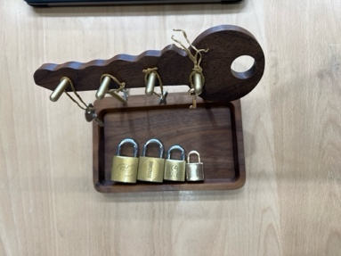

**Locks and Keys**

Materials:

* + Tray or basket, mat, small bowl, 3 locks and keys (different sizes)

Presentation #1

1. Unroll the mat
2. Take the largest lock to the smallest lock and place them in order on the mat (one at a time) standing vertically
3. Take out the bowl with the keys
4. Place them in order on the mat
5. Put the bowl in the basket, set the basket aside
6. Pick up the largest lock in the left hand, pick up the largest key in the right hand
7. Look at the bottom of the lock to determine how the key will go in, insert the key and turn it, lay the key down on the mat
8. Place the lock back on the mat, turn the hasp all the way to the right
9. Repeat with the second and third lock
10. Start back with the largest lock
11. Turn the hasp back to the left, and with two hands push the hasp back into the lock (keeping the lock on the mat)
12. Repeat with the second and third lock
13. Bring the basket back in front of the mat
14. Place the three locks (one by one, largest first) into the basket
15. Take out the bowl from the basket, replace the keys
16. Roll the mat, replace in basket
17. Tell the child it is their turn

###### Notes

* + Children may find it easier to stand up and close the lock if it is large and very hard to close

###### Points of Interest

* + Getting the hasp straight above the hole, and hearing the clicking sound
  + Look at the lock so that you know which way the key goes in

###### Purpose:

* + Develop control and co-ordination of movement
  + Preparation for all other exercises with containers and lids

Age:

* + 2 ½ years - or when starting school

Personal Notes:

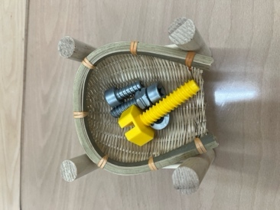**Nuts and Bolts**

Materials:

® Tray, bowl or basket, fabric mat, 4 identical nuts & bolts (not threaded to the head of the bolt)

Presentation #1

1. Roll out mat
2. Take out nuts and bolts and place on the mat in a line from left to right
3. Remove basket from work area
4. Take first bolt by the head with the left hand
5. Unscrew the bolt with the right hand using three fingers
6. Holding the nut vertical, slow down when the nut reaches the end of the bolt (make the twisting movement very clear)
7. Place the bolt down on the mat, place the nut down on the mat
8. Unscrew three of the four, let the child do the last one
9. Take the head of the bolt with the left hand, take the nut with the right
10. Place the nut straight on the top of the bolt and start turning
11. Replace three of the four, and let the child do the last one

**Points of Interest**

111 Not allowing the nut to fall off the end of the bolt

**Purpose:**

* + Develop control and co-ordination of movement
  + Preparation for all other exercises with containers and lids

**Age:**

* + **2** ½ years - or when starting school

**Personal Note**

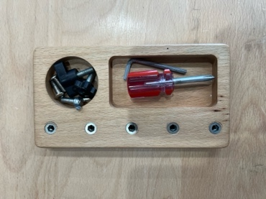**Using a screwdriver**

Materials:

e Tray, mat, wooden block with 4-6 identical screws, screwdriver

Presentation #1

1. Remove blocks from the tray, remove screwdriver, remove mat
2. Place the mat between you and the child, and place the block on the mat along with the screwdriver
3. Take the screwdriver with the right hand, insert it in the top left hand corner screw (hold the screwdriver vertical with the left hand (using the 3 finger pincer method)
4. When screw becomes wobbly, take the left hand away, remove the screwdriver, put it on the mat, and use the right hand to finish unscrewing the screw
5. Place the screw on the mat in an orderly fashion
6. Remove the first 1-2 screws from left to right, then let the child remove the last few
7. When all of the screws have been removed show the child how to replace them
8. Pick up screw with right hand, insert in the top left hand hole and turn until it stands up straight
9. Hold the screwdriver with the right hand, insert in the screw, hold the screwdriver vertically with the left hand, screw it in
10. Replace the first four screws from left to right, top to bottom and let the child do the last few
11. Take the screwdriver off of the mat
12. Lay the mat on the tray, lay the block on the mat, place the screwdriver on the tray

**Notes**

0 To remember the direction to turn the screws; to the right makes it tight, to the left makes it loose

**Points of Interest**

* + Fit screwdriver exactly in the screw

111 Hold screwdriver vertical with the left hand (3 fingers)

* + Watch for the screw to become wobbly, put down the screwdriver, and finish with the hand
  + Replacing the screw in the hole and turning it by hand so that it stands up straight before using the screwdriver to finish it

**Purpose:**

* + Develop control and co-ordination

.., Develop eye-hand co-ordination

* + Preparation for work around the home

Age:

111 2 ½ years - or when starting school

### **Washing Hands**

Materials:

e Liquid soap, towel, cloth, ring holder

Presentation #1

1. Remove jewelry (rings, watches)
2. Roll sleeves up
3. Open cold tap first, can add hot water after
4. Wet hands, give them a shake
5. Dab them on the cloth beside the sink, then use the cloth to close the tap
6. Squirt soap into the palm of a hand (one squirt only)
7. Soap hands all over, fingers included
8. Pick up the cloth, open the cold tap with it, then place it beside the sink
9. Rinse hands until the soap is gone, then give hands a firm shake
10. Pick up the cloth, close the tap
11. Take a large towel, unfold, thoroughly dry hands and fingers
12. Refold towel and hang it up
13. Wipe up drips and dribbles around the sink with the cloth, and hang the cloth on the "damp - to be washed rack"
14. Put jewelry on, unroll sleeves

**Notes**

* + Towels and bar soap are often not permitted in the classroom due to school health regulations - check local regulations
  + Make sure that children wash hands after using the washroom, whenever dirty, and before handling the materials (prevent them from being destroyed with dirt)

**Points of Interest**

* + Opening the tap with the small cloth
  + Shaking hands with a firm shake to remove excess water
  + One little squirt of soap
  + Getting the hands really dry

**Purpose:**

o To wash the hands

* + Hygiene

o Awareness of clean and dirty hands

**Age:**

* + 2 ½ years - or when starting school

**Personal Notes:**

### Face Cream Sample SachetSqueezing a sponge

Materials:

11 Tray, 2 identical bowls, natural sponge, apron

Presentation #1

1. Put on the apron with the child at the table

Natural Sponge

1. Place the bowls on the tray side by side, placing the sponge in the bowl on the right
2. Take the bowl on the left and carry it to the sink
3. At the sink, fill the bowl 1/3 with water
4. Return to the table with the water in the bowl, placing the bowl to the left of the empty bowl
5. Take the sponge from the empty bowl and drop it in the water
6. Let it float, then poke it until it sinks
7. After the sponge has absorbed water, pick it up with the fingers (palm down), and after the water has finished dripping from it, flip it over (palm up) with a little flick of the wrist
8. Move your hand to the empty bowl, flip hand over (palm down), and with all fingers and hand squeeze until the water has stopped dripping
9. Gently drop sponge back into the bowl on the left
10. Repeat until all of the water has been absorbed and transferred
11. Wipe out the bowl and any spills, leave the sponge in the bowl
12. Turn the tray around, absorbing any spills on the tray, and pass the exercise to the child
13. When the child has finished, accompany him/her to the sink with the water bowl, empty the bowl, place it on the small towel (to catch drips), place on the counter, and dry the bowl with the small towel
14. Take the bowl back to the table
15. Wipe out the other bowl with the sponge, stack the bowls on top of each other, and place the sponge in the top one
16. Take apron off, fold it, place on top of the bowls and return the tray to the shelf

###### Notes

* + Never wring out a sponge - always squeeze

###### Points of Interest

* + Watching the sponge change color when it absorbs the water
  + Doing the entire exercise with a minimum of drips
  + If done correctly the hands should not be soaking wet, only damp

###### Purpose:

* + Preparation for all water and sponge exercises

e Strengthening of the hand; the wrist movement; helps the child to be less clumsy

###### Age:

* + 2 ½ years - or when starting school

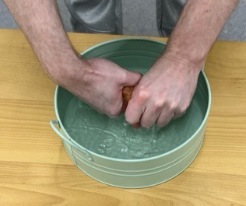

**Wringing a cloth**

Materials:

111 Tray, 2 identical bowls, cloth, apron

Presentation #1

1. Put an apron on
2. Accompany child to the sink with one bowl
3. Fill bowl 1/3 with water, take the bowl back to the table
4. Place the bowl with water on the left, empty bowl on the right
5. Take the cloth, shake it out, and drop it in the water
6. Allow it to soak up water
7. Lift it out of the water, pleat the top of the cloth while still hanging it over the bowl
8. While hanging on to it with your right hand, make a ring with your left hand around the middle of the cloth, and fold the cloth over it
9. Transfer the cloth over to the empty bowl, and wring it out with your right hand from one end to the other
10. Shake it out, and drop into the water bowl
11. Repeat until the bowl is empty
12. Fold cloth into a little pad and wipe any drips and dribbles
13. Turn the tray around
14. Fold sides of cloth in, then fold in half, place between bowls on the tray
15. Hand exercise to the child

**Points of Interest**

* + Folding cloth before it is wrung out
  + As few dribbles as possible
  + If done carefully hands should only be damp
  + The wringing movement twists the wrists in various directions

**Purpose:**

* + Preparation for all other exercises that have a wringing motion
  + Strengthens the hands and the wrist

**Age:**

* + 2 ½ years - or when starting school

Personal Notes:

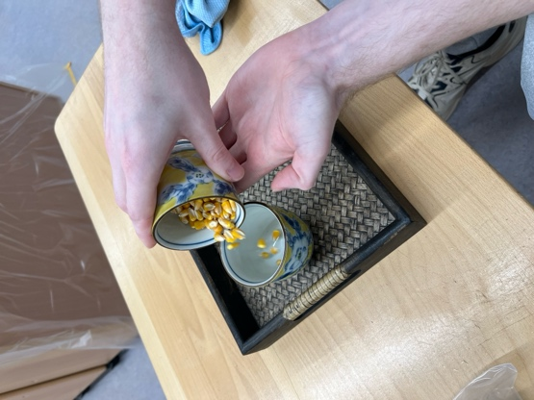**Pouring Rice**

Materials:

"" Tray, 2 identical jugs, one 3/4 full of rice

Presentation #1

1. Jug with rice on the right, empty jug on the left
2. Show child that the jug is full of rice
3. Lift the jug on the right with the right hand and use the left hand to support the bottom of the jug
4. Move the spout of the jug over to the center of the left jug and pour the rice all of the

rice into the jug

1. Look to make sure the rice is gone
2. Put the empty jug down on the tray (to the right of the full jug)
3. If some rice is dropped on the tray or table use the three-finger pincer method and pick up each grain and place into the full rice jug
4. With both hands on the respective sides, rotate the tray 180 degrees so that the full jug is on the right side
5. Give the tray to the child

Notes

0 You need to make sure that the rice is not sticky from the humidity or else it will not pour properly

Points **of Interest**

* + No rice is spilt
  + Jugs do not clang against each other

Purpose:

e Preliminary exercise to that of pouring water

* + Prepare fingers for delicate work by picking up grains that fall

Age:

* + 2 ½ years - or when starting school

Personal Notes:

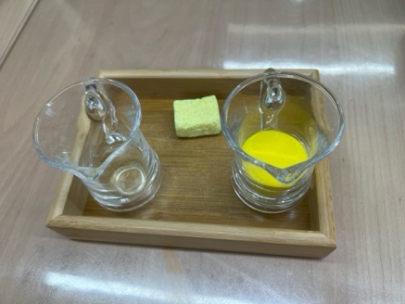**Pouring Water Jug to Jug**

**Materials:**

o Tray, 2 identical jugs, cloth or sponge

**Presentation** #1

1. Jug with water on the right, empty jug on the left
2. Show child that it is a jug with water
3. Lift right jug with right hand, and support the bottom with two fingers of the left hand
4. Bring the spout over to the center of the other jug
5. Pour all of the water - wait until the last drop falls
6. Place pouring jug down on the tray
7. With the sponge, wipe off the spout and any water that spilt then place it behind the jugs on the tray
8. Rotate the tray 180 degrees
9. Pass the tray to the child

**Notes**

* + This exercise must only be given after Pouring Rice has been given and has been mastered

**Points of Interest**

* + The last drop of water falls off of the spout with -a firm but small shake of the jug

**Purpose:**

* + Preparation for the next water pouring exercise
  + Teaching the child how to pour water from one vessel to another without spilling
  + Making the child aware of the necessity of precision in an action
  + Exact muscular control

**Age:**

* + 2 ½ - 3 years - or when the child is ready to handle fragile objects

**Personal Notes:**

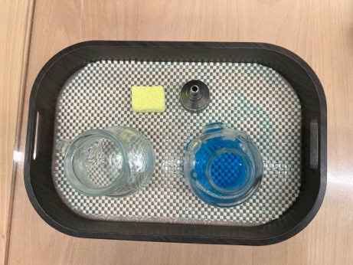**Pouring Water Jug to Glass**

Materials:

e, Tray, jug, glass, cloth or sponge

Presentation #1

1. Jug with water on the right, empty glass on the left
2. Using the Pouring Procedure in Exercise #1, pour water from the jug into the glass
3. Place jug down, wipe spout with sponge
4. Take tray to the sink, and empty the glass (using the proper method of wiping an object off with the towel after pouring water down the sink)
5. Wipe up any spills on the tray with the sponge
6. Top up the jug with water and pass the tray on to the chrld

Notes

e This exercise must only be given after Pouring Water #1 has been given and mastered

Points of Interest

e Stopping at the right level, being able to stop before the glass overflows

Purpose:

* + Preparation for the next water pouring exercise
  + Teaching the child how to pour water from one vessel to another without spilling

e Making the child aware of the necessity of precision in an action

111 Exact muscular control

Age:

* + 3 years - or when the child is ready to handle fragile objects

**Personal Notes:**

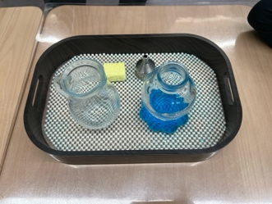**Pouring water Jug to Glasses**

Materials:

* + Tray, several glasses of different sizes, cloth or sponge

Presentation #1

1. Jug with water on the right, 3 empty glasses on the left
2. Use the pouring procedure in exercise #1, pour water into the various glasses stopping before they overtlow
3. Place jug on the tray, wipe spout with the sponge as well as any other spills
4. Take the tray to the sink and empty the glasses
5. Refill the jug
6. Pass the tray to the child

Notes

* + This exercise must only be given after Pouring Water #2 has been given and mastered

**Points of Interest**

* + The different holding capacities of the various glasses

**Purpose:**

* + Preparation for the next water pouring exercise
  + Teaching the child how to pour water from one vessel to another without spilling
  + Making the child aware of the necessity of precision in an action
  + Exact muscular control

**Age:**

* + 3+ years - or when the child is ready to handle fragile objects

**Personal Notes:**

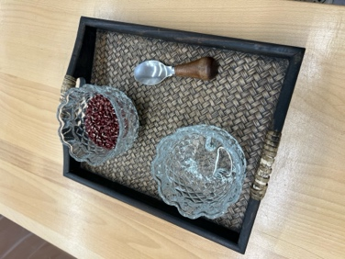**Spooning**

Materials:

- e· Tray, 2 identical bowls (one 3/4 full of peas or beans), spoon

Presentation #1

1. Full bowl is on the left of the tray, empty bowl is on the right
2. Hold the spoon in your right hand, the left hand is keeping the left bowl steady
3. Transfer the beans from the full bowl into the empty one
4. When all the beans have been transferred, place spoon at the back of the tray in between the bowls
5. Rotate the tray 180 degrees
6. Give it to the child

Points of Interest

111 As little noise as possible, not banging the bottom of the bowl

e No spilt beans

e Letting the beans fall closely into the bottom of the bowl

Purpose:

0 Preparation for other exercises

0 Refinement of table manners

" Control and co-ordination of movement

e Eye-hand co-ordination

Age:

111 2 ½ years - or when starting school

Personal Notes:

## Carrying, Rolling and Unrolling Mats

Materials:

* Mat

Presentation #1 - Carrying and Unrolling

1. Take mat from a shelf or basket with two hands
2. Carry the top of the mat cradled in one arm, the bottom end is held in the palm of the hand
3. Place the mat on the floor in a suitable location
4. Kneeling on the floor with the mat vertically in front of you, the open edge of the mat facing left
5. Place your right hand on the roll and left hand on the starting edge of the mat on the floor
6. Roll the mat towards the right; all the while keeping your left hand on the edge of the mat
7. After the mat is completely rolled out, walk around the mat to make sure that it is not on the line, blocking a pathway, or disturbing anyone else

Presentation **#2** - Rolling and Carrying

1. Kneeling at one end of the mat, take the edge and carefully fold it first
2. Continue rolling it to the end, occasionally stopping to make sure that it has rolled evenly on both sides
3. Stand up, pick up the mat with both hands; then cradle the top of the mat in your left arm and use the palm of your right hand to support the bottom end
4. Carry it to the shelf or basket and put it away

###### Notes

e The mats are for activities that cannot be done at the table

* + If something can be done on the table and there is room, it should be done there
  + The mat must be treated as a table; don't walk on it, sit on it, jump over it, or put it on the line

###### Points of Interest

* + Getting the mat out of the container with two hands without it unrolling
  + How to carry the mat
  + Know where it can be placed (need to visualize the size of the mat in order to determine where it will fit)
  + Unrolll mat carefully, roll mat up carefully, with the sides equal and the roll tight

###### Purpose:

0 Preparation for all work with mats

* + Develop eye-hand co-ordination

0 Develop control of movement

=

Age: 2 ½ years - or when starting school

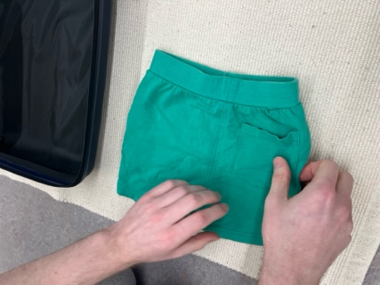**Folding Clothes**

Materials:

€1 Square box, tray, or basket, 4 identical squares of cloth (10" or 12") with guidelines stitched on in contrasting color: 1 median, 1 diagonal, 2 medians, 2 diagonals

Presentation #1

1. Take out the *first cloth*
2. Place the line horizontal on the table
3. Take the bottom comers and fold them to the upper corners Flatten the cloth with fingers along the line
4. The folded edge should be towards you
5. Place at the top left hand corner of the table
6. Take out the *second cloth*
7. Diagonal line starts at the bottom left corner of the table to the upper right hand corner
8. Place the left hand on the top triangle
9. Take the bottom right hand corner and fold to the upper left hand corner
10. Turn the folded edge towards you
11. Flatten the cloth with fingers along the line
12. Place at the top left hand corner of the table
13. Take out the *third cloth*
14. Take two bottom corners and fold them up to the two upper comers
15. Turn the cloth vertically so that the line is facing the child
16. Flatten the cloth with the fingers along the line
17. Place two baby fingers on the edge of the fabric on the line and fold the bottom corners over to the upper corners
18. Flatten the cloth with the fingers along the line
19. Place at the top left hand corner of the table
20. Take out the *fourth cloth*
21. Place left hand on the top left hand corner of the cloth
22. Turn the cloth so that the folded edge is facing you
23. Fold right bottom comer to the left top corner
24. Flatten the cloth with fingers along the line
25. Hold left hand in the top triangle
26. Using the right hand fold bottom corner up to the top corner over the left hand
27. Turn the folded edge towards you
28. Flatten the cloth with the fingers along the line
29. Place at the top left hand corner of the table
30. To unfold simply reverse the procedure for each cloth (unfold the cloths by the corners)
31. Replace it in the tray by sliding it in across the top lip of the tray towards the bottom lip

Notes

('; The cloths should never be smaller than 9" and must be completely square with straight lines

., If the child is having difficulty with the 3rd and 4th cloth, only continue with the 1st and 2nd until the child is ready for the last two which are more difficult

**1**

**2**

**3**

**4**

Points of Interest

o Find different ways of folding

* + Make sure the line is at the edge of the fold

**Purpose:**

* + Direct preparation for folding

0 Indirect preparation for geometry by subconscious absorption of the dividing lines

* + Training in exactness
  + Control and coordination of fingers
  + Development of eye-hand co-ordination

**Age:**

* + 3 years

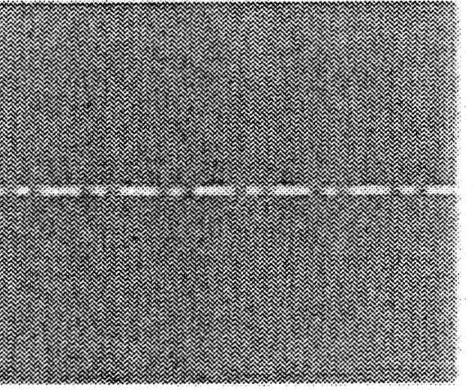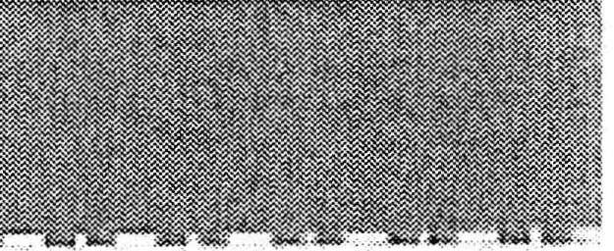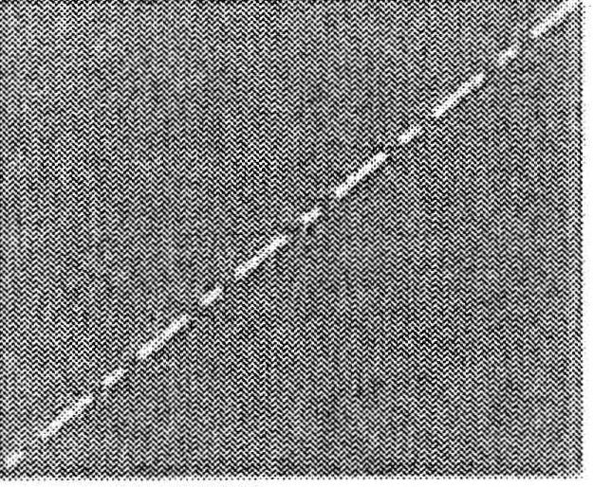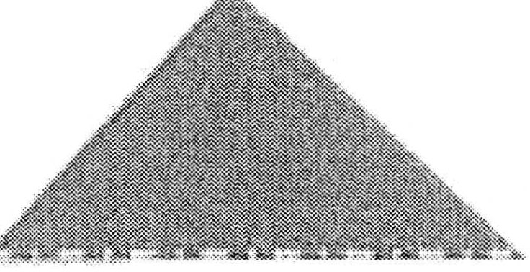

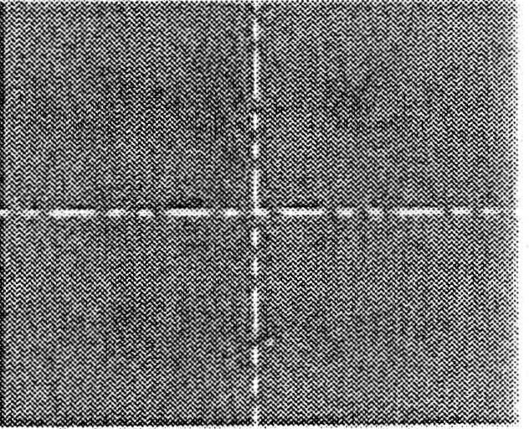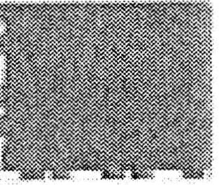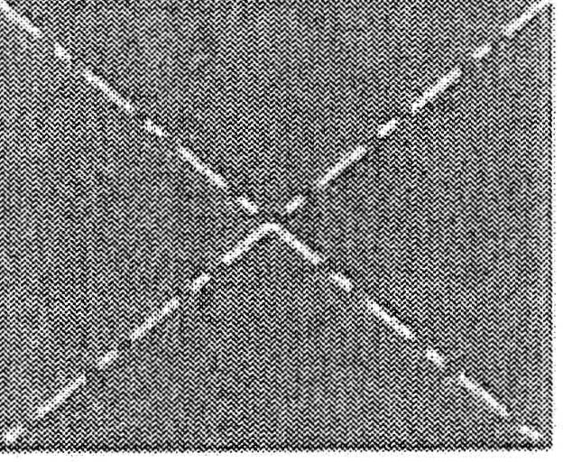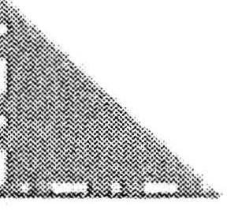

**Personal Notes:**

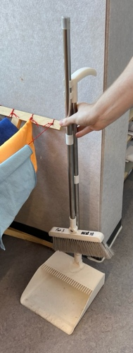

**Care of the Environment Indoors**

**Sweeping**

Materials:

<» 1 small broom, 1 hand brush, a dustpan

Presentation #1

1. Divide the mess that you are going to sweep up into two parts
2. Place a snippet of paper into the center of one mess (it becomes the center point)
3. Fetch the soft broom, and sweep (push) the mess towards the paper snippet
4. When swept into a small heap around the paper, tap the broom to see if anything is stuck to the bottom of it
5. Hang up the broom
6. Take the soft brush and the dustpan to the heap
7. Brush the pile onto the dustpan and when finished, place the brush on the dustpan with the bristles facing the edge - incline the dustpan slightly back to prevent the dirt from falling off
8. Take dustpan to the garbage, place it on the floor
9. Take the lid off of the garbage, pick up dustpan, dump the pile into the garbage, brush off the dustpan with the brush, place the dustpan and brush on the floor
10. Replace the lid back on the garbage can
11. Take the dustpan and brush back to the rack
12. Place the dustpan on the rack, hang the brush, hang the dustpan
13. Allow the child to sweep up the other half of the mess that was originally divided into two parts
14. When finished take the child to the sink and wash your hands

**Notes**

e Show this only after there has been a spill, don't create one just to present the exercise

Points of Interest

* + Sweeping the garbage onto the paper snip it (helps to center the sweeping)
  + Make sure that the broom and brush are not fuH of dust and garbage (the tapping on the floor)

0 Brushing the garbage onto the dustpan (need to push the edge of the dustpan into the floor so that all of the garbage doesn't slide underneath it)

" Hold the dustpan inclined while taking it to the garbage can so that the garbage doesn't fall off

Purpose:

<» Showing care of the environment

Age: 2 ½ years - or when starting school

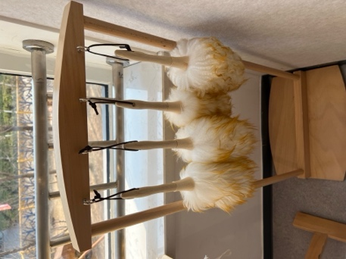**Dusting**

###### Materials:

o Basket, soft brush, hard brush, dust cloth

###### Presentation #1

1. Find object to be dusted, and choose the side that you will dust
2. Dust any corners with the hard brush (loosens the dust)
3. Dust away the loosened dust with the soft brush
4. Make a dust mitt with the dust cloth
5. Always dust from the middle outward to the right, from top to bottom (or with the grain of the wood)
6. The side and back is dusted from top to bottom
7. When you are finished dusting one half of the object, check the dust cloth
8. If the cloth is dirty make sure you shake it out over the garbage, and if it is still dirty put it in the hamper for dirty laundry
9. Replace dust cloth if necessary and hand the child the basket to finish the object

###### Notes

* + Any wood object that is going to be polished must be dusted first
  + Always dust from top to bottom

###### Points of Interest

* + Loosen the dirt with the hard brush
  + Seeing the dust gather on the dust cloth and then shaking it out
  + Seeing the object go from dusty to shiny

###### Purpose:

* + Care of the environment

###### Age:

* + 3 years

**Personal Notes:**

### **Sponging Up Spills**

Materials:

* + Pail, large sponge, cloth, apron

**Presentation #1**

1. Put on an apron
2. Go to sink, take off rings, watch, roll up sleeves
3. The sponge is in the bucket, and the cloth is hanging off the side
4. Place the bucket on the counter, remove sponge and cloth
5. Pour about 1" of water into the bucket
6. Drop the sponge in the water, and place the cloth on the rim
7. Take the bucket to the spill
8. Use half of the spill for the presentation, place bucket near the half you will use. place the cloth on the floor, leave the sponge in the bucket
9. Make sure that the sponge is wet, squeeze water out of the sponge, and place it on the spill
10. Press the sponge down into the spill to help it absorb the water
11. Squeeze the sponge over the bucket, place it in the water in the bucket, let it get wet, squeeze it out, and place it back on the spill
12. Continue this process until the spill is soaked up and in the bucket, squeeze out the sponge, then place the sponge on the floor
13. Place the cloth in the bucket and get it wet, wring it out
14. Place it on the wet floor and wipe it up
15. Place the cloth in the bucket, make it wet, wring it out, and wipe the floor
16. Continue this process until the floor is dry
17. Drop the cloth and the sponge in the bucket, stand up, pick the bucket up, and take it to the sink
18. At the sink: place the bucket on the counter, open the tap with the small towel if hands are wet, rinse the sponge and cloth and place on the counter
19. Close the tap with the small towel, swish the water around inside the bucket, empty into the sink
20. Place the bucket in the sink, put a bit of water in it, swish it around, empty it, place it in

the sink, unfold the small towel beside the sink

1. Take the bucket out of the sink, place it on the towel, wipe inside and out with the sponge
2. Put the sponge in the bucket, place the cloth on the edge
3. Hand it to the child, child sponges up the other half of the spill
4. When finished, fold up apron, and put the bucket away
5. If the cloth is not dirty than it stays on the edge of the bucket, if it is dirty than it is hung on the dirty laundry rack and replaced with a clean one

Notes

f; Wait until a spill happens until you present this activity, and have another child watch the spill so that children don't step in it

II> The child must have mastered other preliminary squeeze and wring exercises before this is presented

*e* If the spill is something sticky: change the water in between the use of the sponge and the cloth

f; If a child has a bathroom accident, do not make the child clean it up. Use a separate bucket; the child is already embarrassed and ashamed... spare the child

Points of Interest

* + Absorbs water into the sponge so that it does not spread

e Using or not using detergent according to the liquid spilt; sticky spills may require a small amount of detergent, non-sticky spills require water

e Submerge sponge in the bucket and squeeze before absorbing the spill

411 Wring cloth well before wiping the floor

**Purpose:**

**o** Care of the environment

Age:

* + 3 years Personal Notes:

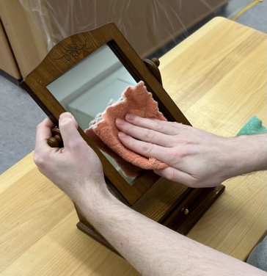**Polishing Glass**

Materials:

* + Basket, mat with napkin ring, polish bottle (with non-toxic polish}, dish, sponge, cloth

Presentation #1

1. Put on an apron, unroll the mat
2. Place objects on mat in order of use (polish, dish, sponge, cloth)
3. Put basket aside, fetch object to polish
4. Shake bottle in right hand, place down, hold with left, unscrew top with the right hand, place lid upside down on the mat
5. With right hand pour a small amount of polish into the dish
6. Put the bottle down and with the sponge, wipe off the top, replace the lid and place back in the proper order on the mat
7. With the right hand, take the sponge and dip the tip of it into the polish
8. In a circular motion, polish the object, top to bottom
9. Watch the polish dry (many polishes turn white), make a mitt with the cloth, and with small but vigorous vertical motions rub off the polish
10. When polish is removed, turn cloth inside out - fold corners in to the center, grasp the small square - you have a buffing pad
11. When finished, go to sink, wash out the sponge and dish, dry dish with the sponge and return to the table, wipe off any residue on the mat
12. Take dirty cloth to the laundry and take a clean one from the shelf
13. Take serviette ring from the basket, take hold of the polish bottle and make sure that the lid is on tight, place in the basket, put in the dish, sponge, and cloth
14. Roll up the mat, replace the ring, take off the apron and fold
15. Hand to the child
16. When the child has finished be sure to wash your hands

###### Notes

* + You need to tell the children that the polish is not to be ingested and that they must wash their hands after this lesson

###### Points of Interest

* + Small amount of polish on the object
  + Having to waitfor the polish to dry before cleaning it off
  + Changing the cloth around when it gets dirty

111 Shininess of the object

* + Rolling the mat tightly enough that it will fit the ring

& The development of logic and thought through layout & sequence of activity

###### Purpose:

**111** Care of the environment

**Age:**

111 3+ years, depending on their ability to focus through the details of the presentation

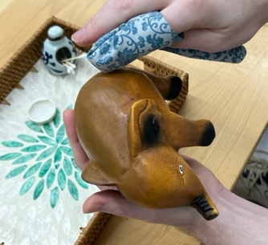**Polishing Wood**

Materials:

Cl! Basket, mat, polish bottle (with non-toxic polish), sponge, thin cloth, rough cloth, soft cloth, apron

Presentation #1

1. Show the child where the lesson is on the shelf
2. Have the child carry the basket *to* the table
3. Put on an apron, unroll the mat
4. Place the objects on mat in order of use from left to right: polish, bowl, sponge, thin cloth, rough cloth, soft cloth
5. Put the basket aside
6. Fetch a wood object to polish
7. Shake the bottle in your right hand, place down, hold with left, unscrew top with the right hand, place lid upside down on the mat
8. With right hand pour a small amount of polish into the dish
9. Put the bottle down and with the sponge, wipe off the top, replace the lid and place back in the proper order on the mat
10. With the right hand, take the thin cloth, make it into a mitt and dip the tip into the polish
11. From left to right in a circular motion, polish the object, top to bottom
12. When finished polishing, leave the mitt in its position on the mat (in its mitt form)
13. With the rough cloth, make a mitt, and rub the object in small vertical strokes, when finished leave it in its mitt form on the mat
14. With the soft cloth make a buff mitt (fold corners in to center) and buff the object
15. Go to the sink and wash out the sponge and dish
16. Dry the dish with the sponge and return to the table
17. Wipe off any residue left on the mat
18. Take the dirty cloths to the laundry and replace with clean ones
19. Take serviette ring from the basket, take hold of the polish bottle and make sure that the lid is on tight, place in the basket, put in the dish, sponge, and cloths
20. Replenish any items that were used
21. Roll up the mat, replace the ring, take off the apron and fold
22. Hand to the child

.23. When the child has finished be sure to wash your hands

Notes

* + Through all of the polishing exercises the child will become aware that different materials in the environment require different care

Points of Interest

* + Choosing an object to polish

e A little bit of polish in the bowl

111 Use three different cloths (need to remember the order of them)

* + Different methods of folding (mitt, sleeve, buff)
  + The object becomes more beautiful

Purpose:

(!) Care of the environment

ci. Awareness of the environment

(!) The development of logic and thought

Age:

0 3+ years, depending on their ability to focus through the details of the presentation

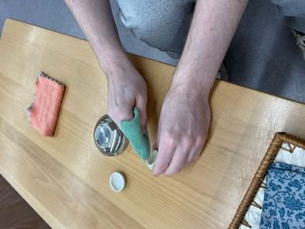**Polishing Metal**

Materials:

0 Basket, mat, polish bottle, dish, sponge, orange stick (a thin stick of wood with tapered ends, used in manicuring - similar to a bamboo skewer), cotton balls, soft brush, soft cloth, apron

Presentation #1

1. Put on the apron, unroll the mat
2. Place objects on mat in order of use (polish, dish, sponge, cotton balls, orange stick, soft brush, soft cloth)
3. Put basket aside, fetch object to polish
4. Shake bottle in right hand, place down, hold with left, unscrew top with the right hand, place lid upside down on the mat
5. With right hand pour a small amount of polish into the dish
6. Put the bottle down and with the sponge, wipe off the top, replace the lid and place back in the proper order on the mat
7. Pick up the stick in the right hand, with a cotton ball in the left hand; pick a little strand of the cotton ball with the tip of the stick and start to roll the stick between your fingertips (pull the cotton ball away from you so that the strand will stay thin), keep rolling until you have a small Q-tip applicator
8. Dip the applicator in polish and apply it sparingly to object; when it is covered, let it dry, it should turn white
9. Remove polish with a cotton ball

1O. If there are any little nooks and crannies or carvings on the object that are holding dried polish - use the brush to clean it - when finished, tap the brush on the mat

1. Use the cloth to buff (if the polish was cleaned off correctly, the buffing cloth shouldn't be dirty when finished)
2. Put the cotton in the dish, take to the garbage, wipe out the dish and any remaining polish with the cotton balls - then throw the cotton out
3. Go to the sink, wash out the sponge and dish, dry dish with the sponge and return to the table, wipe off any residue on the mat
4. Take dirty cloth to the laundry and take a clean one
5. Take serviette ring from the basket, take hold of the polish bottle and make sure that the lid is on tight, place in the basket, put in the dish, sponge, orange stick, cotton balls, soft brush and cloth
6. Replenish any items that were used
7. Roll up the mat, replace the ring, take off the apron and fold
8. Hand to the child
9. When the child has finished be sure to wash your hands

###### Notes

o If the object is going to be eaten off of, it should be washed in warm soapy water

* Two separate lessons (with different color-coding) can be created to halp distinguish the difference between objects made of silver and objects made of brass

Points of Interest

*4>* If done properly the dirt should all come off on the cotton balls and not on the polishing cloth

* The Q-tip applicator created with the cotton ball and orange stick shouldn't be too large

0 Not too much polish should be applied

* Not getting fingerprints all over the object after buffing it

**Purpose:**

e Care of the environment

* Awareness of the environment

e The development of logic and thought

**Age:**

* 3+ years, depending on their ability to focus through the details of the presentation

Personal Notes:

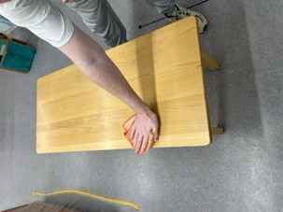**Washing a table**

Materials:

$ Pail, jug, basin, 2 soap dishes, sponge, soap, brush with natural bristles, towel, drying cloth, apron

Presentation #1

1. Choose a table to wash with the child and if need be, take it to an appropriate place to wash (need space to lay materials on the floor)
2. Carry the bucket and basin to the table and place it on the floor (you carry one, and the child carries the other)
3. Put on the apron
4. Unfold the towel and place on the floor at a 90 degree angle to the table
5. Starting at the bottom left hand corner place upon it the soap dish (which holds both the sponge and soap), the second soap dish with the brush, the basin, and the dry cloth
6. Place jug at the top left hand corner, and the bucket in the top right hand comer
7. Take the jug to the sink
8. Take off watch and rings, roll up sleeves
9. Fill the basin about 3/4 full then take it to the table
10. Pour water into the basin (enough to cover the bottom), stand up, and walk around the mat in order to place the jug in the corner, place it down, hold the handle with the left hand, and wipe the spout with the sponge with the right hand, walk back to the front of the mat
11. Take the sponge, wet it in the basin, squeeze it (leave some water in it so that the table will get wet)
12. With even stokes, moving top to bottom, left to right, wet the table with the sponge - if the sponge becomes too dry, wet it again
13. Rinse the sponge in the basin, squeeze, and replace in the dish
14. Take the brush in the right hand, and the soap in the left, hold them horizontally and close to the bottom of the basin; move the brush on top of the soap in a back and forth motion, place the soap back in the dish
15. Stand up in front of the table, and with small circular motions soap the table around the edges, and with big circular motions soap the table in the larger areas (the motions should be differentiated considerably), if needed the brush can be soaped again to finish off the table
16. Go to the basin, rinse the brush, shake it out, and place it back on the dish
17. Stand up, lift the basin, gently swish the water around, walk around the mat to the bucket, and empty the water into the bucket, take the basin back to the front of the mat, set it down and wipe the rim of it with the sponge
18. Stand up, walk to the jug, pick it up, carry it to the basin, pour half of the water into the basin, walk to the back of the mat place the jug down, wipe the spout with the sponge, walk back to the front of the mat
19. Take the sponge, wet it, squeeze it, and with vertical strokes (top to bottom, left to right) wipe the soap off of the table
20. Show the child the soap that collects on the sponge, turn the sponge over and use the clean side to continue wiping the soap off the table
21. After both sides of the sponge are covered in soap, take it back to the basin, rinse it out, squeeze it out, and continue to wipe off the soap, finishing with wiping the outside edge of the table
22. Take the sponge back to the basin, rinse it out, and replace on the dish
23. Take the drying cloth, open up the fold so that it is still folded in half, make a roll with it, dry the table in a vertical motion top to bottom, left to right; wipe, turn the roll over, wipe, undo it, roll it up in the other direction, wipe, turn roll over, wipe etc., walk around the outside edge of the table and dry it also
24. Go back to the mat, unroll the cloth and place in the bottom right hand corner
25. Now begin the clean-up; stand up, pick up the basin, swish water around, take to the bucket, empty into the bucket
26. Walk back to the front of the mat, place basin in spot, walk to the jug, pick it up, take to the basin, and pour the remaining water into the basin
27. Drop sponge into the basin, place soap on the back of the brush
28. Take the soap and sponge dish, take it apart, (show the child how it is taken apart slowly - if it does in fact come apart), place it in the basin
29. Wash the soap/sponge dish, then squeeze the sponge and dry it off with the sponge, dry it off with the cloth, put the dish back together and place it in its spot; replace the soap
30. Take the brush and rinse it off, wash the back and sides with the sponge, rinse the sponge, squeeze it out, and dry the brush off with the sponge, dry it off with the cloth, place it next to the soap
31. Wash the brush dish as before with the soap and sponge dish, replace the brush on it
32. With the sponge wash the scum around the inside of the basin, place the sponge in the dish, stand up, pick up the basin, swish the water around and walk around to the bucket and empty the water into it, take the basin to the front of the mat and set it down
33. With the dry cloth make a mitt and dry the inside of the basin, place the mitt down, turn the basin over with two hands, make a mitt with the cloth, and dry the outside of the basin, place the mitt down, with two hands tum the basin over
34. Walk to the jug, make a mitt, and dry the inside of the jug (and if the outside of it is wet, it can wiped down also), place the mitt down
35. Walk to the bucket, pick it up, take it to the sink, swish it around, empty it into the sink, place in the sink, open the tap with the small towel (hands are probably wet), pour water, close the tap with the towel, swish the water around, empty the water and leave it in the sink
36. Unfold the towel on the counter next to the sink, take the bucket out of the sink and place it on the towel, turn bucket on the towel to dry the bottom of it off, place the bucket on the floor, fold the towel, and take the bucket to the mat and put it in its place
37. Make mitt, wipe the bucket inside, place the mitt down, turn the bucket over with two hands, make a mitt, wipe the outside of the bucket, place the mitt down, and with two hands turn the bucket over
38. Place the jug in the bucket
39. Place both of the dishes in the basin
40. Move the basin and the bucket off of the mat
41. See if the cloth is wet, if so. hang it with the wet and dirty laundry and get a clean one, hang it on the edge of the bucket
42. If the mat is wet, hang it up with the wet and dirty laundry, get a clean one, and put it on the edge of the bucket
43. Turn the table around with the child and let the child wash the other half
44. When the child is finished, take off the apron, fold it and place it on the basin
45. Take the bucket and basin to the shelf (child carries one, you carry one)
46. Put table bacl< to the proper place if it was moved
47. Put rings and watch back on

**Notes**

Any pieces of furniture can be washed using this method

* The child must be capable of completing the other preliminary exercises first: moving a table, squeezing a sponge, wringing a cloth, rolling a mat, making a mitt, pouring water

e The child needs to be able to pour, squeeze, carry a pail, roll, have control and co­ ordination of hand movements

**Points of Interest**

* + Pouring the exact amount of water into the jug and then into the basin
  + Making different swirls of soap on the table
  + Different movements; circular, vertical & horizontal wiping
  + Completing the exercise without making spills or drips on the floor
  + Not putting too much soap on the table
  + When swishing water in the basin and a bucket - not spilling it over the edge
  + Watching the soap come off the table on to the sponge

" Brushing the soap onto the brush (hold close to the bottom of the basin so that it doesn't spray in your face)

**Purpose:**

**o** Care of the environment

* + Control of action
  + Order of sequence
  + Development of logical thinking
  + Acquisition of a variety of movements

##### Age:

* + 4+ years, depending on their ability to focus through the details of this very lengthy and detailed presentation

**Personal Notes:**

### **Sewing on a button**

Materials:

* + Basket, smaller basket with assorted buttons, pin cushion, needle, pin, spool of thread, sewing scissors, fabric squares, thimble

Presentation #1

1. Place in order on the table: basket with buttons, cloth, thread, scissors, pin cushion, and thimble
2. Choose a button and decide where it is going to be sewn on the fabric
3. Take the thread and measure a decent length, cut the thread
4. Take the needle and put the thread through the eye of the needle
5. Pull the thread so that the needle is in the middle of the thread, take the two ends of the thread and tie them in a knot, place the needle and thread down
6. Remove the button from the fabric and in the exact spot where the button was, replace it with the pin by catching a few fibers of the fabric
7. Place the thimble on the middle finger of the right hand
8. Take the needle and thread and insert the needle through the top of the fabric to the back, take the button and place the two holes across the pin, bring the needle back through the fabric from the back to the front coming through one hole of the button
9. Continue this process of sewing from the front to the back 5 times, ending with the needle through the top of the button
10. Tilt the button up to one side, pass he needle through the button hole but not through the fabric, put the needle down, and remove the pin from the fabric, place it in the pin cushion
11. Hold the needle and wrap the thread around the button stem a few times (between the button and the fabric), on the final wrap leave a loop and on the next wrap put the needle through it and let it make a knot
12. Tilt the button to one side again and put the needle through the cloth to the back of the fabric
13. Make a small stitch and knot the thread at the back of the fabric
14. Cut the thread with the scissors
15. remove the remaining thread from the needle and throw it in the garbage
16. Place all items back into the basket and pass it to the child

**Notes**

* + It is important to present this exercise to the child in a manner that you are comfortable with. There are many different methods of hand sewing - choose the method that you're comfortable with. Once the child is comfortable with one method, you can show them another method is they wish to learn
  + The pin is used so that the button cannot be sewn to tightly to the fabric (it makes space between the button and the fabric

**Points of Interest**

Choosing where to place the button

Length of the thread and making a decent knot at the end of the thread

Sewing around the pin

Bringing the thread up through the correct button hole without turning the cloth around to look at the point of entry.

**Purpose:**

Care of self

Care of environment

Age:

4+ years

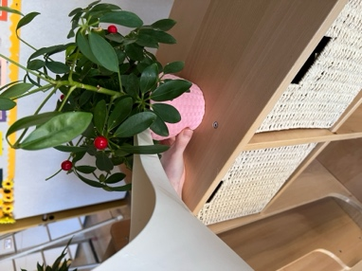**Care of plants**

Materials:

*e* Tray, watering can, atomizer, plant duster, bowl with cotton balls, bowl for water, mat, scissors, small basket, cloth or sponge, apron

Presentation #1

1. This exercise is done standing up
2. Put on the apron, roll out mat
3. Place on the mat in order of use from the top left hand corner to the right basket with scissors (can sit on the edge of the mat}, sponge, duster, watering can, bowl with cotton balls, bowl for water (place in front of bowl with cotton balls), atomizer
4. Choose a plant that requires care, and place off to the right of the mat
5. Look for dead leaves on the plant; when one is found take the scissors, open them slightly, place them on the stem of the dead leaf, follow the stem to the branch and snip it there. If the entire branch is dead, follow the stem all the way to the soil, and then snip it off there
6. Place all of the dead leaves in the basket, wipe the scissors off with the sponge right away, and place them in front of the basket
7. With the duster, dust the leaves (hold the leaf in the left hand and the duster in the right hand), dust the stems if needed
8. When finished dusting, pour a little bit of water into the bowl, take a cotton ball, dip it in the water, squeeze it out, and wash the leaves (hold the leaf in the left hand, and the cotton ball in the right); if the cotton puff is dirty, get a fresh one and continue
9. See if the plant needs water - test the soil with fingers, if needed, use the watering can and water the perimeters of the pot
10. Spray the plant with the atomizer
11. Begin clean up: take the leaves in the basket to the compost or garbage, return the basket to the table
12. Take the duster outside or to the garbage and shake it out
13. Refill the jug with water, empty the bowl of the water and dry it with the sponge, check that the atomizer has water
14. Throw out the cotton balls that were used
15. Replace the materials back on the tray, roll the mat
16. Give the exercise to the child
17. When finished, fold apron and place on the tray, put the plant away

###### Notes

$ To be successful with this lesson, children need to be able to pour, wash gently, use scissors.

* + Tell the children that plants are living things and need care
  + Choice of plants is important, should have a large variety with various characteristics in the environment (plants that require lots of water, those that require little water, with flowers, without flowers, hairy leaves (cannot be dusted or washed), etc.
  + All plants should be at the height of the children
  + You should know the names, instructions for care, place of origin and be able to offer that information to the children when they ask

fll Have reference books on plants for the older children to read

e Another important exercise is potting plants; you can use any broken pottery, china, etc. to put in the bottom of the pot

**Points of interest**

* + Dusting along the stems if needed

e Cutting leaves - cut one at a time, cut at end of stem " The amount of water that the plant needs

* + Always keeping water in the containers (plants don't like water fresh from the tap)

e Looking for dirt on the cotton balls

**Purpose:**

e Care of the environment

* + Preparation for botany

**Age:**

* + 4+ years

**Personal Notes:**

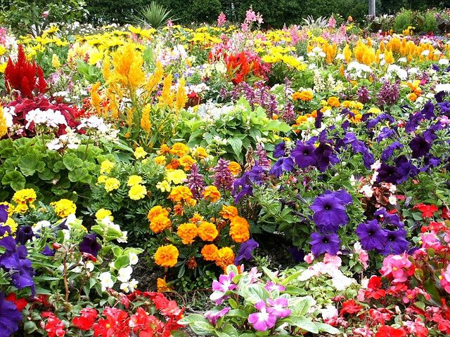**Flowers**

Flowers are very ceremonial; they are a part of birth, of death, and of celebrations such as weddings. There is a tremendous amount of activity and history around flowers. It is wonderful for the children if there are always flowers in the classroom.

Flower arranging is a versatile activity, no arrangement is ever wrong and flowers are always beautiful.

The ideal situation would be for the children to have an outdoor garden if the facilities exist.

Fresh flowers are best as they need to be cared for by the children. Another possibility for the children to grow their own flowers would be a small indoor garden, the right conditions are necessary of course. If fresh flowers are not possible, then silk flowers can be bought and they will last throughout the year. If you are going to use silk flowers, try and re-arrange them periodically so that they make a new arrangement. It is nice for the children if they are not always looking at the same flowers - they will eventually not notice them if they are always the same.

When arranging flowers you will need many containers of varied sizes. The containers

do not have to be expensive. You can use cans, pots, or anything that will hold water. A good collection of things, will hold the flowers in place in the containers: gravel, marbles, pine cones, sand, any broken pieces of pottery or China that have broken in the class. Don't throw out any breakables that should happen to be broken in the class; they can probably be used as a base for this exercise.

If you are able to have an outside garden it is important to teach the children the names and the proper care for each flower. Show the children how and when they can pick the flowers, and how they should carry them back into the classroom.

A few general rules:

* Always pick flowers one by one
* You will need good scissors to cut the stems
* A rose needs to be cut down where the leaves are growing in 5 sets, and it should be cut on an angle

0 Some flowers close when they are picked, and some flowers will close at night as they would if they were still outside

* Never pick flowers when the sun is shining on them
* When measuring the flowers to fit into the container, it is important to re-cut the stem even if just a little bit (the stern has closed from when it was cut the first time and it needs to be reopened so that it will take the water in properly when in the vase; or else it will wilt and die
* Cut the sterns under water so that the flower will instantly suck up the water instead of closing off the stern in shock
* Remove the leaves that will sit below the water line or else they will rot and disturb the balance of nutrients in the water

"' The leaves should be carefully pulled off one at a time, not stripped off, or it will damage the stem

"' After flowers have been picked they need fresh water every day

e When finished with a vase or container it is extremely important to wash out the container or it will stain the glass, and grow bacteria

" A stand for the vase or container of flowers is a nice finishing touch

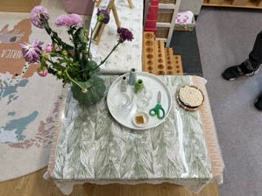**Flower Arranging**

###### Materials:

* + Large supply of assorted vases, frog, tray, scissors, shallow bowl, jug, mat, atomizer, funnel, container with flowers, sponge, drying cloth, apron

###### Presentation #1

1. Put on the apron, roll out mat
2. Place objects on mat in order of use: scissors, jug, sponge, funnel, atomizer, space, bowl, space, cloth
3. Go pick flowers
4. Bring flowers to the mat, place at left of the bowl
5. Pour water into the bowl, wipe jug with sponge
6. Go find vase, and bring to the table
7. If the vase requires a funnel to fill it with water, then place it in and pour water into it; if the vase is transparent, you can watch the level rise, and if it is not transparent you will have to look inside the funnel to see the water level
8. Dab the funnel off on the cloth and then wipe it out with the sponge
9. The vase should be sitting need: to the cloth, on the edge of the table
10. Choose the flower or green that will go in first
11. Hold the flower or green next to the vase to measure what needs to be cut off, take the scissors, hold them open on the stem where it is going to be cut, close the blades so that they are embracing the stem, with the scissors around the stem move it over the bowl, insert the stem where it is going to be cut into the water, and snip the stem off under the water
12. Pick off any leaves that will be below the water line in the vase, and place them into the bowl
13. Place the scissors on the cloth
14. Insert the flower or green into the vase, repeat the steps for the following flowers or greens
15. When finished spray the flowers with the atomizer
16. Begin clean up: take the bowl with water, stems and leaves and take it to the compost/garbage to throw out the stems and leaves
17. Empty the water from the bowl into the sink, bring the bowl back to the table, wipe it with the sponge, then dry the inside and out with the dry cloth in a mitt (flipping the bowl over to dry the outside), then place on the tray
18. Replace the jug, sponge, and funnel on the tray
19. Wipe the scissors on the sponge, and then dry the open blades between the cloth, replace them on the tray
20. Replace the atomizer on the tray
21. If the cloth is wet, hang it up and replace with a clean one
22. Dry the mat off, roll, and replace in the tray
23. Take the vase with the flowers in it to a shelf or table to display
24. Give the exercise to the child

Notes

e Never place the flower arrangement on the exercise tray

e Know the names of the flowers

@ Have a wide variety of elements, give the child a choice

ci The child who makes an arrangement must maintain the arrangement after making it

Points of Interest

* + Variety of choice (choose flower and vase)

e Using the funnel appropriately, watching the water level rise

0 Measuring the height of the flower before cutting it

0 Cutting the stems under water in the bowl

*o* Removing the leaves that would be under the water line

###### Purpose:

* + Development of the aesthetic sense

Cl) Awareness that things need care (water, sun)

Age:

0 4+, when the child can pour, cut, roll, make a mitt etc.

Personal Notes:

### **Cutting Snippets**

###### Materials:

* + Tray, scissors, basket, supply of paper strips

###### Presentation #1

1. The tray is assembled at the shelf
2. Place the scissors, the basket, and two strips to be cut onto the tray
3. Take the tray to the table
4. Place the basket in front of you
5. Remove the scissors, the basket, and the strips of paper from the tray, move the tray aside
6. Show the child how to hold the scissors (use the thumb and second finger, the scissors

lean on the index finger)

1. Take the strip of paper between the thumb and the 2 fingers of the left hand approximately 1 1/2" from the end of the strip
2. Pick up the scissors in the right hand
3. Cut the paper with the scissors and allow the snippets to fall into the basket underneath the hands
4. Continue cutting until the scissors reach the fingers of the left hand holding the paper; close the scissors on the paper slightly so that it does not cut the paper, but so that it holds the paper steady while the fingers can move back on the strip and take hold of it again
5. Continue cutting in this manner until the strip is completely cut into little snippets
6. Place the basket and the scissors onto the tray and pass it to the child
7. When the child is finished cutting, place the scissors, and the basket onto the tray and carry the tray to the shelf, place the tray down, take the basket over to the snippet container (used to make the center of a dry spill) and pour the snippets into the container
8. Place the scissors and the basket on the shelf and place the tray in its spot

###### Notes

* + When cutting snippets only the tips of the scissors cut the paper, not the entire blade

###### Points of Interest

* + The way you hold the scissors (thumb & middle go in the handle)
  + Holding the paper in the scissors as you move your fingers backwards on the paper
  + Using the points of the scissors only when cutting
  + Cutting the snippets, the same size

###### Purpose:

* + Learning how to cut and manipulate the scissors

###### Age:

* + 2 ½ years

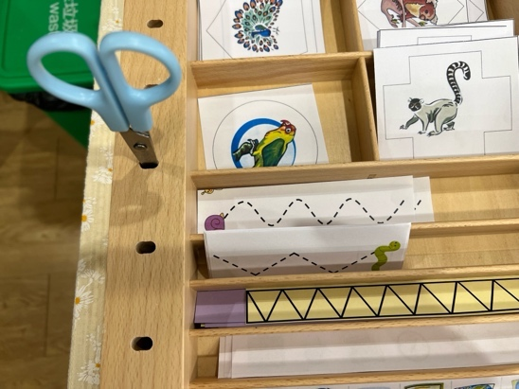**Cutting Lined Paper**

###### Materials:

* + Tray, scissors, paper with different lines

###### Presentation #1

1. The tray is assembled at the shelf
2. Place the scissors, and the paper with the different lines to be cut onto the tray
3. Take it to the table
4. Remove the scissors, and the paper from the tray, move the tray aside
5. Show the child how to hold the scissors (use the thumb and second finger, the scissors lean on the index finger)
6. Take the paper in the left hand and start to cut along the lines on the paper
7. When the scissors reach the end of a line and the strip of paper falls to the table, place the scissors onto the tray and place the strip of paper into the basket along with the rest of the lined paper
8. Pass the tray to the child
9. When the child is finished, take the tray with the scissors, strips of paper, and any of the lined paper that is left back to the shelf, place the strips of paper into the basket that contains the strips, place the scissors on the shelf, and if there is any lined paper left put it in its place as well

###### Notes

* + Must be able to cut snippets prior to this lesson
  + The lines should be fairly thick, it helps the children when they are first starting
  + Begin with straight lines, then when that skill has been mastered, move on curved lines, zigzags and then various shapes

" Using color-coded paper helps the children remember which skill they are working on (i.e. Green paper for straight lines, orange for zigzags, yellow for curvy lines, red for shapes)

* + Pin-Poking is another exercise that can be presented around this time. The children can trace the map shapes or you can use a large variety of themed shapes for challenging cutting and pin-poking.

###### Points of Interest

* + Precision of cutting right down the middle of the line
  + Using the whole blade for cutting lines

###### Purpose:

., Learning to cut on a specific path

###### Age:

* + 3 years

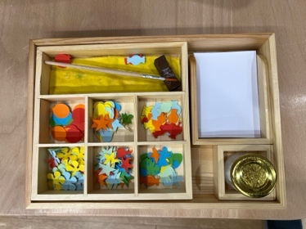**Pasting**

Materials:

* + Tray, awl, glue, glue applicator, pencil, paper towel, paper for pressing, construction paper, shapes to be pasted

Presentation #1

1. At the shelf choose a piece of construction paper and a shape, place on the tray, take the tray to the table
2. Place the construction paper and the pressing paper to the right-hand side of you
3. Take out the paper towel and unfold it, place on the table
4. Take out the holder
5. Remove the pencil, glue, applicator and awl
6. Take the construction paper and the shape, and place them on the mat in front of you, decide where on the construction paper the shape should go (aesthetic decision)
7. Using the pencil, mark a cross on the construction paper where the shape is going to be placed
8. Using the pencil, mark on the shape a cross where it will line up with the cross on the construction paper
9. Place the pencil down, and place the shape to the left of the construction paper with the cross up
10. Open the glue pot, placing the lid upside down in front of the pot
11. Take the glue applicator and slightly dip it into the glue (touch the surface of the glue lightly and the last drop hanging on the end of the applicator will usually fall)
12. Place the applicator down in its spot, and replace the **lid** on the glue pot
13. Pick up the awl in the right hand, take it in the left hand, and place the tip of it on the center of the cross on the shape, take the applicator in the right hand and apply the glue to the shape, put the applicator down, change the awl to the right hand, lift the shape slightly off of the mat and with the left thumb and index finger take hold of the shape by an edge, place the awl down, and with the right hand take the shape from the left hand where the cross is between thumb and index finger by an edge
14. Place the shape on the construction paper
15. Place the pressing paper on the shape, make a fist with the right hand (palm facing left, edge of little finger down), press and rub on the pressing paper
16. Peel the pressing paper off and place it to the right of the mat
17. Write your name on the backside of the construction paper with the pencil, place the pencil down, and place construction paper off to the right
18. Clean off the applicator; hold the applicator in the right hand and wipe it off on the pressing paper which is in the left hand, place the applicator down, and fold the paper in half, pick up the applicator in the right hand and wipe it off in the fold of the paper, place the applicator down, pick up the awl in the right hand, poke it through the folded pressing paper twice and then place it down, place the paper down .
19. Place the tray in front of you, take off the stand, and replace the glue. awl, pencil, and applicator, paper towel if clean; if the paper towel is not clean then it must be thrown out and replaced with a clean one
20. The pressing paper must always be thrown out and then replaced
21. Pass the tray to the child

Notes

0 The child only pastes one shape on the paper during the presentation; after the presentation is mastered, the child is free to create a11work using the glue applicator

* + In order to have visually wonderful art work Maria Montessori believed that one "needs an eye that sees, and a hand that obeys"

Points of Interest

" Choosing the color of the paper, choosing the shape, and choosing where to paste the shape (deliberate choice)

o The amount of glue used (if pressing paper is stuck to the shape than too much glue was used)

* + Putting the glue on the shape and not on the paper mat underneath it
  + Quickly wiping the glue off of the applicator before it dries

###### Purpose:

* + Preparation for all kinds of works of art, including decorating school work and projects

###### Age:

* + 3 years

###### Personal Notes:

**Care of Environment**

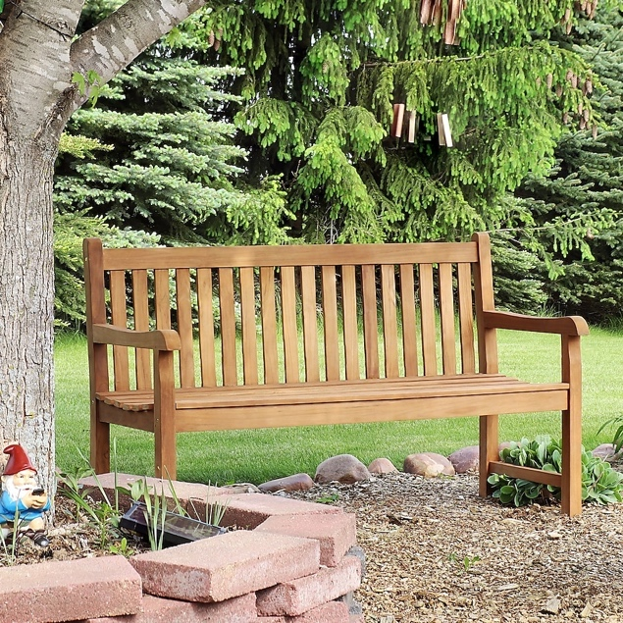**Outdoors**

It is important to prepare any outside activities following the principles of the indoor activities.

The ideal outdoor environment is one which is natural; lots of trees and bushes, places to sit, flower and vegetable gardens, and if possible, a pond that can be observed (as living things

prepare their own environment in the pond).

1. Each exercise should have an **inner aim,** either immediate or ulterior.
2. All materials should have a **point of interest.** The points of interest guide the child, engage them and help lead the child towards awareness of the concepts being shown in the materials.
3. The materials must be physically and developmentally **in proportion to the**

**children.** All rakes, shovels, brooms, and any other tools that the children will be using to tend to the outside environment should be in proportion to the size of the children so that they can work successfully.

1. Tools should be **color coded** as it gives an identity and a sense of completeness to each activity. The tools required for each activity (rake for leaves and a basket to collect the leaves in) should be the same color.
2. Activities need to **reflect the child's culture.** If the leaves don't fall off of the trees because there isn't a change of weather from summer to fall, then there shouldn't be an exercise in raking and collecting leaves. Keep activities reality based.
3. Everything must be in **complete sets** and independent from one another. Tools should not be shared between activities. A place for everything and everything in its place - just as it is in the indoor environment.
4. Gardening tools must be placed within reach of the child's eyes and hands. The children must see it to be attracted to it, and be able to reach it in order to repeat the activity over and over again. (I.e. The window boxes that are blooming with flowers must be at the children's level in order for them to take care of them and enjoy the beauty of the flowers that are a direct result of their gardening labor.
5. Materials must be placed iogicaUy in order to further refine the children's sense of logic. Outdoor activities should be in sequential order (as best is possible). Water activities should be near things that require water, witl1 an accessible water source. The garden tools should be stored close to the garden, along with a weeding bucket, gloves and kneeling mat.
6. Call attention to the child's awareness of the environment. Avoid plastic where ever possible. Instead, use real rakes, shovels, watering can and brooms. Using real materials calls forth the children's awareness of movement and their control over their own body and movements within the environment.

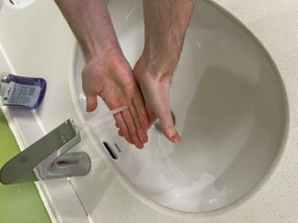

***Care of the Person***

## Washing Hands and Nails

Materials:

* + Basin, jug, dish with soap, dish with a nail brush, dish with sponge, hand towel, dry cloth, ring holder, hand lotion, pail

Presentation #1

1. Go to sink with jug, fill with water, take to the table and place in front of the basin
2. Sit down., take off jewelry and roll up sleeves
3. Pour a small amount of water into the basin, wipe the spout with the sponge
4. Take the nail brush in the left hand and the soap in the right hand, dip the brush in the water, and then brush the soap onto the brush in the basin, place the soap into the dish
5. Transfer the brush to the right hand, dip nails of the left hand into the water, put finger tips together and brush them with the brush and then brush each nail individually
6. Rinse the nails, then rinse the brush
7. Transfer the brush to the left hand
8. Pick up the soap in the right hand and brush the soap onto the brush, put the soap back into the dish
9. Dip the nails of the right hand into the water, put finger tips together and brush them with the brush and then brush each nail individually
10. Rinse the right hand, transfer brush to the right hand and rinse, give it a shake and put back on the dish
11. Dip nails, shake and dab them on the hand towel
12. Stand up, pick up the basin, swish the water around, and empty it into the bucket, put the basin on the table, wipe off drips with the sponge, sit down
13. Pour water into the basin (half of what is left), place the jug down, and wipe with the sponge
14. Wet hands in the water, give them a shake, pick up the soap, soap hands, put the soap back on the dish
15. Lather up the soap on the hands
16. When hands are soapy rinse them in the water
17. Shake them, and holding the left hand over the basin, take the right hand and dab them on the towel, take the towel and open it up, dry the hands properly with the towel, when hands are dry fold the towel in half and place it next to the basin
18. Stand up, pick up the basin, swish water, empty it in the bucket
19. Put the basin on the table, wipe the edge with the sponge, put the sponge down
20. Sit down
21. Take the jug and empty the remaining water into the basin, set the jug down and wipe the spout with the sponge
22. Drop the sponge into the water
23. Take the brush off of the dish and place it on the sponge dish
24. Wash and dry the brush dish, using the sponge (if it absorbs well, if not, use the dry cloth to dry it)
25. Wash and dry the brush, replace the brush
26. Take the soap and place it on the sponge dish
27. Wash and dry the soap dish, replace the soap
28. Take the sponge dish, wash and dry it
29. With the sponge wash out the inside of the basin, squeeze the sponge out and replace on the sponge dish
30. Stand up, pick up the basin, swish the water, empty the water in the bucket, set the basin down on the table
31. Sit down, with the dry cloth make a mitt and dry the inside of the basin, set the mitt down, turn the basin over with two hands onto the folded towel, make a mitt, and dry the outside of the basin, wipe the table where the basin sat to dry off any water, place the mitt down
32. Take the jug and set it in front of you, make a mitt and dry the side closest to you including the inside of the jug, set the mitt down and with two hands turn the jug around so that you can dry the other side, place the mitt down, tum the jug back around, and place it back in its spot, with two hands take the basin, turn it over and place it down on the table
33. Stand up, tuck chair in under the table, take the bucket to the sink, swish the water, empty it, place it in the sink, pour some water into it, lift it out, swish the water around, empty it, place it in the sink, open up the towel beside the sink and place the bucket on it to dry the bottom off
34. Take the bucket back to the table, make a mitt with the cloth and dry the bucket using the same method as drying the basin (except on the floor)
35. Check the towels for wetness, if wet than hang on the dirty laundry rack and replace

with a clean one (one cloth at a time)

1. Sit down, squirt some lotion onto the palm of one hand, rub it into your hands
2. Replace jewelry, roll down sleeves
3. Let the child try the exercise

###### Notes

* + The hand is an instrument of intelligence, it is important to keep the hands clean

###### Points of Interest

111 Pour only a little water when cleaning nails

* + Soaping brush as much as necessary without spraying the soap everywhere
  + Getting enough, but not too much soap on hands
  + Rinsing hands properly, the cupping motion with the hand is important as it holds the water and gets the other hand wet

e As few drops of water on the table as possible

* + Shaking the excess water off the hands

1111 Brushing under the nails to remove dirt

Purpose:

* + Care of self; self-respect, deriving joy out of cleanliness, beauty, and dignity

II> 3 years, when the child learns to fill a jug, empty pail, pour, make mitt

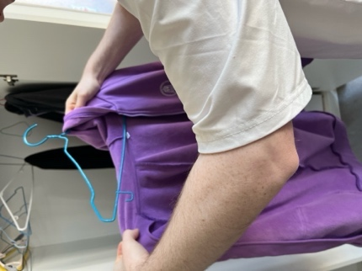Hanging Clothes on a Hanger

Materials:

.., Hanger, jacket or shirt

Presentation #1

1. To take the jacket off: shuck the shoulders of the jacket towards your back
2. With hands in front of the body have the left hand take the cuff off the right sleeve and pull slightly so that the right hand passes out of the right cuff
3. Repeat this motion with the right hand so that the left hand is released from the cuff, pass the right hand to the back and have the left hand meet it there
4. With the left hand take the right cuff and pull the right arm completely out of the jacket
5. Pull the jacket off to the left side and bring it around the front of the body
6. With the right hand, take bath of the cuffs and pull the jacket off of the left arm
7. When the left hand is free from the jacket take the collar of the jacket and hold the jacket up while letting go of the cuffs that were in your right hand
8. To hang the jacket u1-1: lay the jacket on the table facing up
9. Standing behind the top collar of the jacket bring the right side of the zipper or buttons to the middle of the jacket, do the same with the left side of the jacket
10. Take the hanger in your right hand and with the left hand open the left side of the breast of the jacket and slide the hanger into the shoulder, repeat this for the right side of the jacket
11. When the hanger is set into the jacket do up the zipper or the buttons
12. Take the hanger by the hook, hold it up and hang it on the rod or hook
13. Reverse this process to take a garment off of the hanger

###### Points of Interest

* + Shucking the shoulders back

(!I Holding the two cuffs without dropping the garment or brushing it on the floor

e Have garment hung properly on the hanger (shoulders hanging squarely)

###### Purpose:

**o** Care of self

0 Care of environment

Age:

" 2 ½ years, or when starting school

Personal Notes:

### Cleaning Shoes

**Materials:**

* + Paper mat, basket, shoe polish, stiff brush, soft brush, dauber, polishing brush, buffer, small paper, apron

**Presentation #1**

1. Explain that this exercise is for soft leather shoes only
2. Put the apron on
3. Open paper mat, lay it out on the floor
4. Lay upon it in order of use: hard brush, cloth, dauber, polish (neutral), polish brush, buffer, small paper
5. Find a leather shoe, place left hand in it, and pick it up
6. With the right hand pick up the hard brush to remove any dried mud and dirt, when finished tap the brush on the mat, and place it back on the mat
7. Make a mitt from the cloth, wipe *off* the dust, and place it back on the mat
8. Show child how to open polish tin with the butterfly latch on the side of the can, put the butterfly latch back to the horizontal position, take the Hd *off,* and place both the lid and the tin on the mat
9. Pick up the dauber in the right hand, tap it on the polish, put the dauber down with the bristles facing up, and close the polish immediately
10. Pick up the shoe in the left hand pick up the dauber in the right hand and tap the brush all over the shoe until the polish is distributed all over the shoe, then daub it all in using small circular motions, put dauber down and wait for the polish to dry
11. When the polish is dry take the large brush and vigorously brush the shoe until it is warm to the touch
12. When all of the polish has been brushed in and the shoe looks shiny, place the polish brush down
13. Take the buffer and bring the shine out all over the shoe, then place the buffer down
14. Cleanup: take the hard brush and give it a tap on the mat, place it in the basket
15. Give the cloth a shake and place it in the basket
16. Make sure that the polish tin is closed properly, and place in the basket
17. Take the small paper and place it in the middle of the mat, pick up the dauber and wipe it off on the small piece of paper, place the dauber in the basket
18. Place the polish brush in the basket
19. Take the buffer and place it in the basket
20. Determine if the mat is soiled or not, if soiled fold it up with the small piece of paper in it, and throw into the garbage bin and replace the mat with a clean one
21. If the paper mat is not soiled and can be used again, stand up and pick it up along with the small paper on it (allow the mat to bend in the middle), take it over to the garbage bin, place the paper mat on the floor, take the lid off of the garbage bin, take the paper and shake it over the bin allowing the small piece of paper to fall into the bin, place the mat on the floor, replace the garbage bin lid, pick up the mat and return to the table
22. Fold the mat and place in the basket
23. Replace the small paper and place in the basket
24. Hand the basket over to the child
25. When finished fold apron, place on top of the basket and wash your hands

**Notes**

e Make sure the children only use leather shoes with leather polish

Points of Interest

0 Brushing off the caked on mud

e Make sure all dust is removed

0 Opening polish tin with the butterfly latch

@ Tapping, not scooping the dauber in the polish

ci Closing polish immediately so that it doesn't evaporate and dry up

e After applying polish the whole shoe should be dull looking

" Brushing the shoe when polish has dried and the shoe becomes shiny

111 Carrying the mat to the garbage bin without the dust and dirt falling off

**Purpose:**

* + Care of person

**Age:**

@ 4 years, when child can use the polish safely

**Personal Notes:**

**Dressing Frames**

Dressing frames are wooden frames with two pieces of material fixed on to opposing sides which close at the center of the frame with different fastenings.

Dressing frames isolate one particular skill, and are a repetition of that one particular skill.

1. The frames should be presented in order, unless a child shows a great interest in learning a different one.
2. The earlier the frames are presented the better. It will allow for greater independence.
3. For all dressing frames always start at the top of the frame and work your way down, except with the zipper frame, of course.
4. To lift the frame, take the top of the frame with your right hand, gently lift it off of the dressing frame rack, and carry it to a table with two hands as you would a tray.

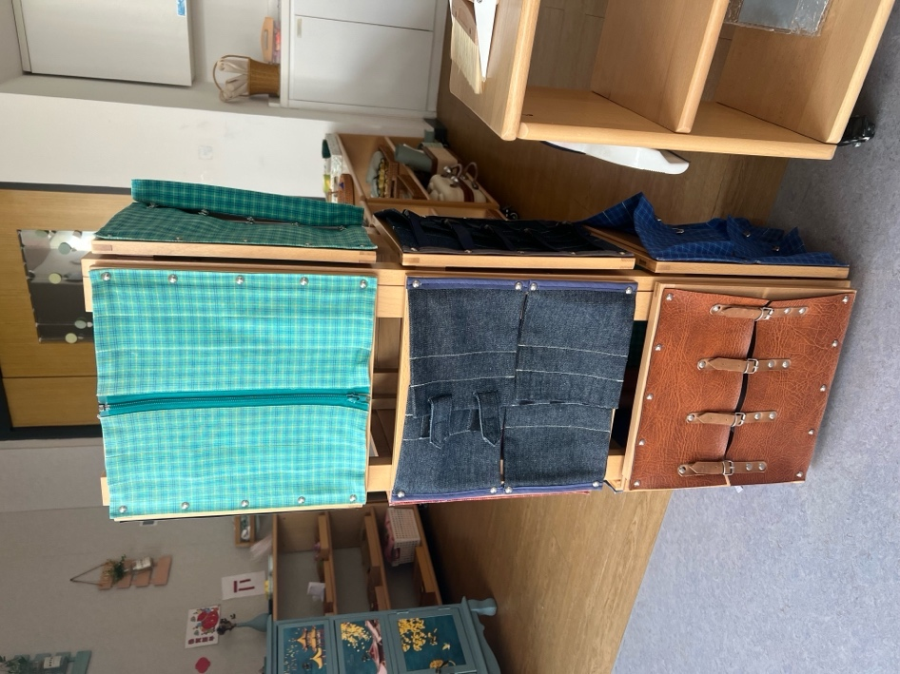

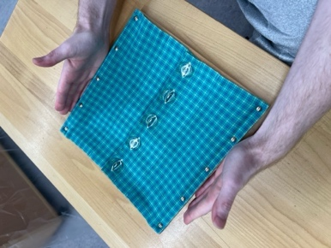**Large Button Dressing Frame**

###### Materials:

* + Large button dressing frame

###### Presentation #1

1. Place the dressing frame in front of you; with the side with the buttons to the left, the side with holes on the right
2. With the left hand; the thumb and index finger take the edge of the material alongside the top hole
3. With the right hand; the thumb and index finger take the right side of the button
4. With your right hand tilt the button and push it through the hole with the index finger while at the same time slightly lifting the edge of the fabric with the left hand
5. When the button has passed through drop the edge of the material with left hand and move to the next button
6. When all of the buttons are open, use the thumb and index finger of both hands, the left hand will take the top left hand comer of the right panel, and the right hand will take the bottom right hand corner of the right panel, open the right panel up, open the left panel in the same fashion
7. Close the panel in the exact same manner, starting with the left panel
8. With the right hand lift the edge of the material with the holes, turn it over slightly so that you can see the button hole, with the left hand take the button with the thumb and index finger and push it through the hole
9. Let go of the edge of the material with the right hand
10. With the right thumb and index finger take the button that is peeping through the hole, take the edge of the material with the left thumb and index finger and pull the button and the material slightly away from each other at the same time
11. Complete the remaining buttons
12. Pass the frame to the child

###### Points of Interest

* + Slipping the button through the hole when undoing it, and doing it up

###### Purpose:

* + Caring for self and others
  + To acquire co-ordination of movement
  + Care of person
  + To acquire skill in fastening and unfastening clothing, thereby helping the chrld's development of independence

###### Age:

e 2 ½ years - or when starting school

###### Personal Notes:

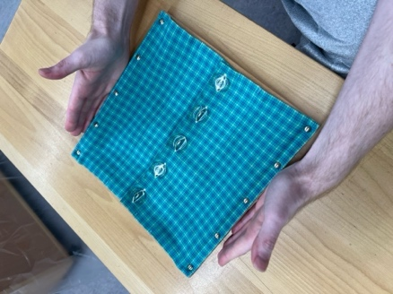

Small Button Dressing Frame

Materials:

0 Small button dressing frame

Presentation #1

1. Place the dressing frame in front of you; with the side with the buttons to the left, the side with holes on the right
2. With the left hand; the thumb and index finger take the edge of the material alongside the top hole
3. With the right hand; the thumb and index finger take the right side of the button
4. With your right hand tilt the button and push it through the hole with the index finger while at the same time slightly lifting the edge of the fabric with the left hand
5. When the button has passed through drop the edge of the material with left hand and move to the next button
6. When all of the buttons are open, use the thumb and index finger of both hands, the left hand will take the top left hand corner of the right panel, and the right hand will take the bottom right hand corner of the right panel, open the right panel up, open the left panel in the same fashion
7. Close the panel in the exact same manner, starting with the left panel
8. With the right hand lift the edge of the material with the holes, turn it over slightly so that you can see the button hole, with the left hand take the button with the thumb and index finger and push it through the hole
9. Let go of the edge of the material with the right hand
10. With the right thumb and index finger take the button that is peeping through the hole, take the edge of the material with the left thumb and index finger and pull the button and the material slightly away from each other at the same time
11. Complete the remaining buttons
12. Pass the frame to the child

**Points of Interest**

* + Slipping the button through the hole when undoing it, and doing it up

**Purpose:**

* + Caring for self and others
  + To acquire co-ordination of movement
  + To acquire skill in fastening and unfastening clothing, thereby helping the child's development of independence

**Age:**

* + 2 ½ years - or when starting school

**Personal Notes:**

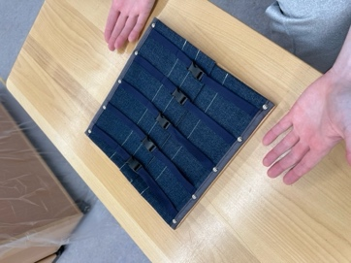**Snap Dressing Frame**

Materials:

* + Snap dressing frame

**Presentation** #1

1. Lay the frame down with the top layer of fabric being on the right
2. Start with the snap at the top of the frame; with the right hand lift both pieces of the material at the top of the frame together
3. The left index finger goes under the cloth behind the snap, and the thumb beside the snap
4. The right index finger is on the snap with the thumb under the edge of the material beside the snap; pull the snap open
5. Release the material and move to the next snap
6. Place the left index finger beside the snap, the right index finger is on the snap with the thumb under the materials beside the snap - pull the snap open with the right finger and thumb
7. Repeat this until you have reached the bottom snap which is unsnapped in the same manner as the first snap
8. When they are all unsnapped, open the right flap, then open the left, close the left, then close the right
9. With the right hand lift both pieces of the material at the top of the frame
10. The left index finger goes under the cloth behind the snap, and the thumb beside the snap
11. The right index finger is on the snap with the thumb under the edge of the material beside the snap - show the child that the snaps are lined up, then press them together
12. Release the material from both hands and move to the next snap
13. The left index finger is placed on the top edge of the material beside the snap to hold the material in place
14. The right index finger is on the top of the snap, and the thumb is under the flap of the material beside the snap
15. Lift the material in the right hand to show the child that there is a little knob on the snap, line it up with the hole in the bottom snap and press down on it with the index finger - **SNAP**
16. Repeat until you have reached the last snap, snap up the last snap in the same manner that the first snap was

**Points of Interest**

* + The snapping sound
  + Placing the knob of the one side of the snap into the indentation of the other side of the snap
  + Holding the index finger close to the bottom snap when pulling the snap apart to prevent damage to the fabric surrounding the snap

**Purpose:**

Caring for self and others

* + To acquire co-ordination of movement
  + To acquire skill in fastening and unfastening clothing, thereby heiping the child's development of independence

**Age:**

o 2 ½ years - or when starting school

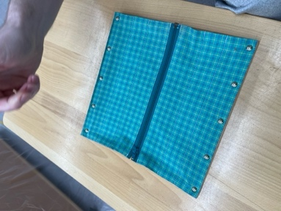**Zipper Dressing Frame**

Materials:

61 Zipper dressing frame

Presentation #1

1. Unzip - take the top of the material holding both sides with the

left hand, with the thumb across the zipper and the fingers underneath

1. Lift the pull tab with the right thumb and finger and slide it half way down
2. Release the material at the top, and bring the left hand down to just above the slider body, place it palm down on the material to hold it down in place
3. Pull the pull tab down the rest of the way until it reaches the retainer box
4. Push the slider body over the retainer box, put left thumb at the end of the stop
5. Release the pull tab and take the material on both sides at the bottom (left thumb on the left side of the zipper with fingers underneath, and the right thumb resting on the slide with the fingers underneath)
6. Pull the insertion pin out of the retainer box
7. Open the right side of fabric, open the left side of the fabric, close the left side, then close the right
8. Zip up - with the right hand, take the slider body (the thumb on top and the finger underneath), with the left hand hold the retainer box
9. Slide the insertion pin into the retainer box all of the way
10. Hold both sides of the material at the bottom with the left hand, and using the right hand pull the pull tab until the slider body is half way up

1.2. Release the left hand from the bottom of the retainer box and place it on the material just under the slider body

1. Pull the slide tab all of the way up to the top of the zipper, press the pull tab down against the slider body and remove both hands

Points of Interest

* + Holding the two pieces of material steady

e Placing the hand halfway down the material

* + Pulling the slider body against the retainer box at the bottom, and holding it there as you slide out the insertion pin
  + Making sure the insertion pin is fully inserted into the insertion box before starting to zip it up

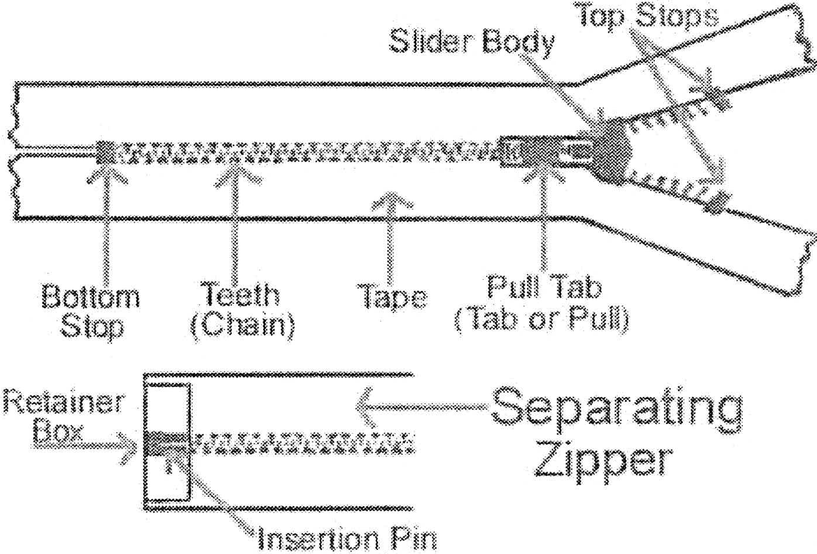Purpose:

Ill Caring for self and others

® To acquire co-ordination of movement

@ To acquire skill in fastening and unfastening clothing, thereby helping the child's development of independence

Age:

e 3 years

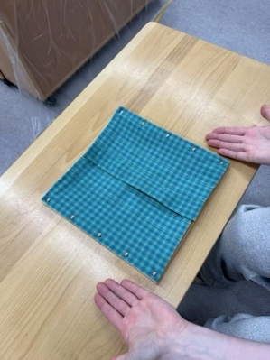Hooks and eye Dressing Frame

**Materials:**

* + Hook and eye dressing frame

**Presentation #1**

1. With the right hand place the thumb on the underside of the edge

of the material, and the index finger on the upper edge of the material

1. With the left hand, place fingers underneath the material and place the thumb on the edge of the eye, pressing down slightly (the eye will stand up a bit)
2. Push both sides of the material towards each other, and push the hook off of the eye with the right hand
3. Release the material from both hands, and move on to the next hook and eye
4. When you have unhooked the bottom hook and eye, open the right side of the material with both hands, then the left, close the left, then close the right
5. To unhook subsequent hooks & eyes; place the right hand as in the first hook and eye, the left index finger is placed on the edge of the eye and the thumb is not used
6. Open the right side of fabric, open the left side of the fabric, close the left side, then close the right
7. To hool< up the top eye; take the eye side of the material with the left hand, hold the eye in place with the thumb, the fingers are behind the material; take the hook side of the material with the right hand, hold the thumb on the top side of the material, the fingers are behind the material supporting the hook
8. Pulling the material together, line up the hook and the eye, hook the eye, and release the material with both hands
9. To hook up subsequent hooks & eyes; place the left index finger on the eye, press

**down**

1. Take the hook side of the material with the right hand, hold the thumb on the top side of the material, the fingers are behind the material supporting the hook
2. Pulling the material together, line up the hook and the eye, hook the eye, and release the material with both hands

**Points of Interest**

* + Make sure the hook is through the eye
  + Pulling material together to unhook the hook from the eye

**Purpose:**

* + Caring for self and others
  + To acquire co-ordination of movement
  + To acquire skill in fastening and unfastening clothing, thereby helping the child's development of independence

**Age:**

* + 3 years

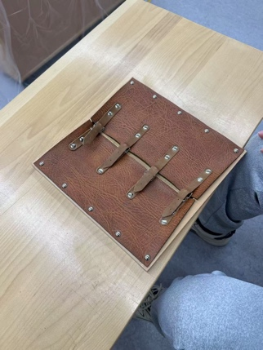**Buckle Dressing Frame**

Materials:

* + Buckle dressing frame

Presentation #1

1. To unbuckle;
2. With the left hand take the point of the strap
3. With the right hand hold the guard upright
4. Push the strap through until there is a hump in the strap
5. Release with both hands
6. With the right hand pull the strap through the guard and release
7. Hold the frame steady with the left hand, take the point of the strap in the right hand and pull it strongly until the pin is released, without letting go of the strap take the pin in the left hand, release the right hand and pull the buckle off the strap with the pin
8. Take the strap in the right hand, with the left hand lay the pin flat over the glide and then lay the strap flat over the buckle
9. Grasp both sides of the material together and open them, then close them together, flatten out all of the pins
10. **To buckle up;**
11. Take the strap in the right hand and the guide in the left hand
12. Push the strap through the guide and release with both hands
13. With the right hand, take the strap, press down on the frame, and pull the strap down until the pin lines up to the hole
14. With the left hand, put the pin in the hole, let go
15. With the strap in the right hand and the guard in the left, push the strap through the guard, make a bridge (as in the unbuckling), release both hands, and with the right index finger push the strap flat down

###### Points of Interest

* + The processing of unbuckling:
    - Pull strap hard enough that the pin will release from the hole
    - Removing the buckle from the strap by holding the pin
  + The processing of buckling:
    - Pulling the strap hard enough so that the pin comes to the correct hole
    - Putting the pin in the hole

###### Purpose:

* + Caring for self and others
  + To acquire co-ordination of movement

e To acquire skill in fastening and unfastening clothing, thereby helping the child's development of independence

* + 3 years

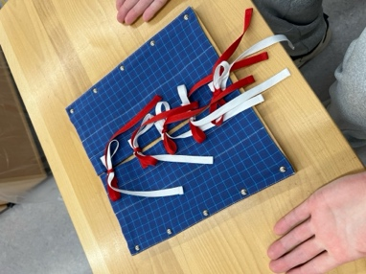

Bow Dressing Frame

Materials:

0 Bow dressing frame

Note: This lesson is written up using a bow frame that has 2 different colored laces

Presentation #1

1. Start with the white lace sewn the left, and red lace sewn on the right
2. Untie by pulling at the ends
3. Begin with the bow at the top of the frame
4. Loosen the knot and slightly separate the red lace from the white lace - stick the right index finger under the knot, through the tunnel and pull up, keep pulling until you reach the ends of the lace; place the middle finger over the strings to prevent them from falling; take the white lace over to the left, and the red lace to the right
5. Repeat Step #4 for all of the bows
6. Open the right side of the material, then the left, close the left, then the right
7. Starting with the laces at the top of the frame: cross the white lace below the red from the left to the right, and the red lace over the white from right to left, repeat for all of the bows
8. Take the end of the white lace in the right hand and where the material meets, slide the lace under the tunnel and pull through; hold the left lace tight and pull the lace through and over to the right, repeat for all of the bows
9. With the right hand, tal<e the left lace with thumb and index finger and make a bridge by lifting the lace slightly, with the left thumb and index finger make a loop, let the loop droop over to the right, take the right lace and lay it across the bridge and place towards the back,
10. With the right index finger tuck the lace that lay across the bridge under the bridge, release both hands from the laces to allow the child to see the lace peeking through the bridge
11. With the right thumb and index finger take the red loop, and with the left thumb and index finger take the white take that it part way through the bridge and pull it through far enough to make a bow
12. The bow is made; pull the ends and straighten the bow
13. Repeat Steps #8 through #12 with the remaining laces

Notes

* + There are many ways to teach tying bows; regardless of the method you teach, you must break your movements down into segments so that the child has a very clear understanding of the various movements required to master the skill

###### Points of Interest

® Mal,e sure when untying the bow that the lace does not go through a loop, or it will become a knot

"' Putting the lace through the bridge

Purpose:

111 Caring for self and others

o To acquire co-ordination of movement

e To acquire skill in fastening and unfastening clothing, thereby helping the child's development of independence

Age:

ci 3 years

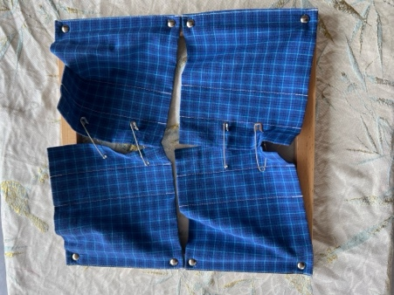

Safety Pin Dressing Frame

Materials:

e Safety pin dressing frame

Presentation #1

1. Take the pin out; push the pin through the material all the way towards the bottom of the pin
2. Take the head of the pin with the left thumb and index finger, with the right thumb press against one side of the pin to release the tip of the pin from the head
3. Let go of the pin with the left hand and place it on the material just underneath the pin in order to hold the material down
4. With the right thumb and index finger, pull the pin out of the material, close it; holding on to the head with the left thumb and index finger, and using the right thumb and index finger to squeeze the tip of the pin into the head
5. When the pin is closed place it down on the table to the right of the frame
6. Remove all of the pins in this manner
7. Open the material; right side, then left side, close the left, then the right
8. To put the pins in; take a pin in the right hand from beside the dressing frame
9. Open it as previously described
10. With the left hand place it behind the material with the thumb on top of the material
11. With the right index finger and thumb push the pin through the two layers of material
12. Guide the pin through to the top of the material using the left index finger that is under the cloth
13. Close the pin and lay the pin flat

###### Points of Interest

* + Guiding the pin through with the left index finger
  + Pinning both of the cloths
  + Pinning the material without pinning yourself
  + Watching the tip of the pin come out from the head
  + Getting the tip of the pin in the head on the first try
  + Pin with the same amount of material through the body of the pin for all of them
  + Laying the pins down on the material all the same way

###### Purpose:

* + Caring for self and others
  + To acquire co-ordination of movement
  + To acquire skill in fastening and unfastening clothing, thereby helping the child's development of independence

###### Age:

* + 3 years

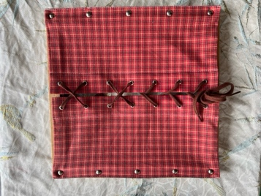**Shoe Lacing Dressing Frame**

Materials:

o Shoe lacing dressing frame

Presentation #1

1. Undo the bow as learnt at the bow frame
2. Take out the laces one at a time; holding the cloth with the left hand pull out the lace with your right hand and lay it off to the side that it is now laced on
3. When you have reached the last two holes pull the lace from the back of the eyelets - pulling both out at once
4. Stretch the lace out in the air between your right and left hand, then stretch it out on the table in front of the frame
5. Open the fabric, first the right, then the left, close the left, then close the right
6. Pick up the lace in what looks like the middle with the right hand, make it even
7. With the right hand, put the tips of the lace through the back of the eyelets
8. Pull them through the front of the eyelets, and pull them down towards the base of the dressing frame, even them off
9. Lay the laces across the sides of the frame
10. Take the right tip in the right hand, take the edge of the material on the left at the eyelet and lift it slightly so that the eyelet can be seen, and so that the right hand can guide it through the eyelet on the left, the left hand then holds the material flat down so that the lace can be pulled through
11. Repeat this procedure for the lace on the left, using the right hand to guide it through the eyelet, and the left hand to lift the material
12. Place the left hand at the top of the dressing frame, and with the right hand pull both of the laces down towards the bottom of the dressing frame, tighten them, and even them out
13. Lay the laces across the table, one on either side
14. Repeat this until you reach the last two holes, lace them up, and then make a bow as described with the bow frame
15. Pass the frame to the child

**Points of Interest**

* + Keeping the tips of the laces equal
  + Having the laces go in the same direction (i.e. Right is always under and left is always on top)

**Purpose:**

o Caring for self and others

* + To acquire co-ordination of movement

o To acquire skill in fastening and unfastening clothing, thereby helping the child's development of independence

##### Age:

* + 3 years, after the bow frame has been mastered

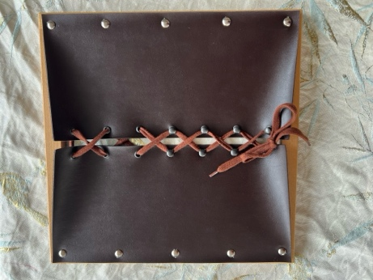**Skate Lacing Dressing Frame**

**Materials:**

e Skate lacing dressing frame

**Presentation #1**

1. Untie the bows are you learnt with the bow frame
2. Loosen the first two hooks, holding the lace cross the hands and lay the laces down, continue this until you reach the eyelets
3. Unfasten the eyelets as in lacing #1, pull out the lace
4. Open the fabric, close the fabric
5. Lace the eyelets as in the shoe lacing dressing frame
6. Holding the laces, cross the hands, hook the lace under the hooks with the index fingers (both laces at the same time), cross the hands, hook, etc.
7. On the last hook, cross, hook, cross, make a bow

**Notes**

* + Must be able to do the bow frame
  + Must be able to do the lacing #1 frame

Points of Interest

* + Keeping the tips of the laces equal
  + Having the laces go in the same direction (i.e. Right is always under and left is always on top)
  + Cross hands to undo and do up
  + Make sure that the lace doesn't slip out from under the hook as you work your way down the frame; must keep laces taunt

**Purpose:**

* + Caring for self and others
  + To acquire co-ordination of movement
  + To acquire skill in fastening and unfastening clothing, thereby helping the child's development of independence

Age:

* + 3 years, after the bow and the shoe lacing frame have been mastered

Personal Notes:

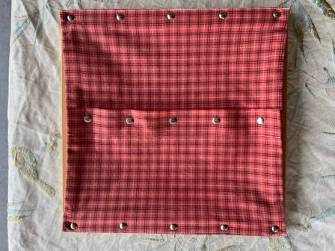**Buttons With Hooks**

Materials:

Buttons with hook dressing frame

Presentation #1

1. Undo the buttons; take the hook in the right hand
2. Take hold of the edge of the material in the left hand above the button
3. Put the hook through the hole with the hook facing down, when it's through the hole, tum the hook slightly so that it is facing away from the button
4. Move the hook past the button
5. Turn the hook to loop it around the stem of the button
6. Slightly tilt the edge of the button that is furthest from you in a downward position (away from you)
7. Slip the upper edge of the button down through the hole- the button will come out
8. Repeat with the remaining buttons
9. To do up the buttons; take the hook in the right hand
10. Take hold of the edge of the material in the left hand above the button
11. Put the hook through the hole with the hook facing down, when it's through the hole, tum the hook slightly so that it is facing away from the button
12. Move the hook past the button
13. Turn the hook to loop it around the stem of the button (can use the left index finger to set the button up for the hook to loop around)
14. Slightly tilt the edge of the button that is furthest from you up (towards you)
15. Slip the upper edge up through the hole - the button will settle into the hole
16. Repeat with the remaining buttons

Points of Interest

* + Not getting the point of the hook caught in the stem of the button

i& Must twist and turn the hook in order to prevent the hook from catching on the stem of the button

**Purpose:**

°' Caring for self and others

e To acquire co-ordination of movement

0 To acquire skill in fastening and unfastening clothing, thereby helping the child's development of independence

**Age:**

* + 3 years, after the bow and the shoe lacing frame have been mastered

Personal Notes:



Blowing Nose

Materials:

* + Tissue

Presentation #1

1. Pull out a tissue with two hands, using the thumbs and index fingers
2. Place the tissue flat upon the right palm, and with the left index finger make a little depression in the tissue (collects the mucous)
3. Using both hands draw the tissue up to the face against the nose
4. With the index finger of the right hand cover the right nostril and blow
5. With the index finger of the left hand cover the left nostril and blow
6. Take the tissue away from the nose, gather it up in the right hand and give each nostril a quick wipe with the tissue
7. Dispose of the tissue
8. Wash your hands

**Points of Interest**

e Blowing through each the nostrils and not the mouth

* + Make sure that the mucous is in the tissue and not in the hands
  + Disposing of the tissue in the garbage

e Washing hands

**Purpose:**

**e** Care of self and dignity

Age:

* + 2 ½ years, or when starting school

**Personal Notes:**

**Grace and Courtesy**

* Grace and courtesy underlie all of Montessori pedagogy.

® Courtesy is different in all cultures.

There is an innate respect in children, which can be destroyed or nurtured when growing up, depending on the environment.

e There should be a feeling of respect and delight for each other's existence in the classroom.

<> In nature, there are no rewards and punishments, only consequences.

* Treat children with the respect they deserve and help them make their way through the world with grace and courtesy.

e Children love the formalities of grace and courtesy.

e Teach the children grace and courtesy by always showing them how to act gracious and courteously, never give up an opportunity to be courteous and gracious. The children will learn from watching your actions.

Greeting and Introduction

1. It is important to greet each child with a handshake and make eye contact as they enter the classroom each morning. (i.e. "Good morning Jonathan. How are you this morning?")
2. Welcome any short stories that the children have to offer. Don't hurry them off to start their work. Let them know that you feel that they are important; they will work better if they feel important.
3. Always introduce a newcomer into the classroom; never just seat them somewhere and ignore them. "Children, if you would please pause for a moment I would like to introduce you to someone."
4. When introducing people one on one, introduce the younger person to the older

person first. I.e. Facing the adult - "Mrs. Montessori, f'd like you to meet our new student Stephen Blackwell." Now turning to the child - "Mrs. Montessori is our school Administrator."

1. Be sure to make the proper introductions and offerings:

«> "Hello {name of guest), I am (name of teacher). I am the primary teacher here at Montessori School. It's a pleasure to meet you."

* + "Please come in and make yourself comfortable."
  + "May I take your coat for you?"
  + "Please have a seat."
  + "I would like to share with you our guidelines for observing in the classroom. This will ensure it's a positive experience for you and the children."
  + 'Tm happy to take a few minutes after your observation to answer any questions you may."

**Offering to a guest**

When you know in advance that you will have a guest in your classroom (observing the children), make sure you have a little table set beside the chair that they are going to be seated in. This allows for them to place down their glass of water that the children will undoubtedly offer them, without having to hold it for the entire visit.

Children love the opportunity to practice preparing drinks/food and serving guests. It's recommended that you set guidelines in the classroom prior to having guests so that a guest is not offered several drinks and snacks during their short visit. Usually a glass of water and a small snack is sufficient.

Teach the children how to serve a snack to a guest Use a tray and a real glass where possible. Be sure to include a napkin.

* "Can I offer you a drink of water and a snack?"
* "I see you have finished your water, can I get you another glass?"

o "lf you are finished your snack, I would be happy to take your plate."

#### Giving and Receiving Cornplirr1ents

<> Always respond to someone who has given you a compliment. A simple "Thank you", or "Thank you, you are very kind" is sufficient.

"' Before giving a compliment it is important to consider if the person will find the compliment rude or not (some cultures don't take compliments well).

C) Be careful with truths - sometimes they can be mean and hurtful.

* Never insult or tease anyone who you don't love and know very well. "' Always laugh with someone and not at them.

e Watch sarcasm with children, it can wilt their soul and teach them to be rude.

#### Making Way for Someone to Pass

' -· --

e Be careful to allow people who are trying to pass you, to pass you without getting in their way. Stop and step aside to indicate to them that you allowing for them to pass by.

* When holding the door for someone; let the person pass and then you may walk through the door.
* If you see someone who has held the door for one person to pass through and several people have also since passed through, do not also pass through the door. Instead, offer to hold the door for the person who held it for everyone else.

#### Interrupting Someone

* It is essential to teach the children that it is rude to interrupt someone when they are speaking. Since all lessons/presentations are to be given without interruption this rule is very important in a Montessori setting.

e When a child wishes to speak with the teacher, but the teacher is busy (either speaking with someone, or presenting a lesson), the child can gently place or touch their hand on the teacher's shoulder. The teacher should acknowledge the child by a glance or gesture, and when the teacher is free he/she should address the child right away.

@ Adults must respond to children when they are polite with their interruptions or the child will learn that they need to yell and scream and tug on the teacher to get their attention.

e In the event of an emergency (i.e. A child is hurt or is going to be hurt) children must be taught how to interrupt. I.e. "Excuse me Mrs. Smith. I'm sorry to interrupt you, but I'm afraid Sam is going to hurt himself. Can you please help me?"

Sneezing Yawning and Coughing

Grace and courtesy should be shown by all individuals on a daily basis. Simple techniques help to keep everyone healthy.

1. Sneezing: When you feel a sneeze coming on, you can use your pointer finger to put pressure on the skin between the base of your nose and upper lip. This pressure will calm the nerves that run between the bone and the skin and will usually stop a sneeze. If you're unable to stop the sneeze and you're unable to sneeze into a tissue, then turn your body away from the people around you and sneeze into your sleeve (bend your elbow and sneeze into the crook of it). Find a tissue to blow your nose, throw the tissue away and finish by washing your hands.
2. Coughing: Turn your body away from the people around you. If you are unable to cough into a tissue, then cough into your sleeve (bend your elbow and sneeze into the crook of it).
3. Yawning: Always put your hand up to your mouth and yawn into it quietly and discreetly.

**Movement**

Walking on the line

El The line is called a line, not a path.

4\1 The line is an ellipse, not a circle.

«> The line should be no more than 1 inch in thickness, preferably narrower.

*If!;* The line should never be sat upon, and never used to call a circle upon it. As well, furniture and mats should never be placed upon it.

1£, There should be a shelf for walking on the line materials.

e Walking on the line is peaceful, and in a normalized Montessori classroom there will always be one child walking or dancing on it

lil Walking on the line should be started with the children early on.

Exercises for Walking on the Line

1. Walk individually with natural steps, looking down at the line
   * Add the arms swinging naturally

e Walk with the head up, using peripheral vision

**Point of Interest:** keeping balance on the line

1. Walk in a small group
   * Walk naturally

e Keep equal distance between the children who are walking

Point of Interest: keeping equal distance by adjusting the speed of the walk

1. Walk heel to toe

Point of Interest: not falling over

1. Walk holding a flag

e Holding two flags with arms stretched out straight in front

**Point of Interest:** not falling and looking ahead

1. Walk holding one glass of water with two hands " Holding one glass of water with one hand

Cl! Holding two glasses of water Point of interest: water shouldn't spill

1. Walk holding a weighted string with arm stretched out straight in front Point of Interest: weighted string shouldn't sway
2. Walk with something on your head

G Start with a soft bean bag

* + Use a more solid object such as a book

Point of Interest: object shouldn't fall off the head

1. Walk holding an easily rung bell

G Hold the bell close

l!I Hold the bell far out front

Point of Interest: bell shouldn't ring

1. Walk with something in your hand and something on your head Point of Interest: objects shouldn't sway or fall
2. Walk with a lit candle
   * Walk without allowing the flame to go out
   * Walk without allowing the flame to move

**Point of Interest:** flame shouldn't go out, or move

1. Walking or dancing to music
   * Trot, gallop, prance, etc.

**Point of Interest:** keeping the rhythm of the music in the movement

**Purpose of Walking on the Line exercises**

* + To achieve equilibrium
  + To correct posture defect

e To acquire good posture and gait

**Age:**

-2 ½ years - begin as soon as school it started.

The Silence Game

$ Read: The Secret of Childhood, page 131-133

e Silence is a "point of arrival".

0 The Silence Game should not be attempted until there is certainty of basic success.

* All of the exercises that have movement are indirect preparation for The Silence Game.

0 The children must have control over their will, they need to be able to inhibit movement, concentrate, and must have a sense of ease about oneself and their body.

(!) The silence game should bring a sense of joy, of achievement, and self-reliance.

* The silence game is a measure of normalization of the class.

o The silence game is the summation of all that is necessary in the development of the individual to bring about that integrity, which is the wholeness of the personality.

* If all the sensitive periods are allowed to develop, the capabilities and capacities all integrate and normalize the child; the result is the whole personality is formed.

###### Preparation

All preparation exercises help the child achieve control and the children can then participate in the silence game.

* Teaching the children to sit quietly and still.

**o** Show them how to arrange themselves comfortably on the chair or floor; if using a chair center yourself on the chair (important that the children have chairs which allow their feet to touch the floor).

* Children need the opportunity to hear the silence and the sounds of silence
  + Ask a small group of children to sit quietly and see what they can really hear... ask them to listen to rain on the window panes, birds chirping, the snow falling, the sound of nature, and the sound of traffic).
  + Allow the children to experience the silence without you (the teacher) calling forth things for them to be aware of (don't ask them what they smell, hear, or feel, just let them be).

e Once the children are a cohesive unit working towards a common goal for the good of all (collective will), the silence game can be played.

###### Directions to play The Silence Game

* Tell the children that together you are going to make silence
* Ask the children to sit on the floor comfortably, sitting somewhere that they can get up easily
* Tell the children to sit with their eyes closed and listen for their name; when they hear their name they are to come over quietly and sit down
* Quietly, the teacher walks outside the classroom (or to the other side of the room) and allows for a minute or so of silence

c., Then gently, quietly, the teacher whispers a child's name

e When a child's name has been called the child gets up from where they are sitting, and quietly walks over to the teacher and takes a seat on the floor

* After the last child has joined the new group everyone can enjoy a final moment of silence together.